ALG TECHNOLOGY
CONG TY TNHH CONG NGHE ALG | Ho Chi Minh City, Vietnam
From Drawing to Export – End-to-End Mechanical Manufacturing & Export Coordination
About us
ALG Technology is a Vietnamese manufacturing and export coordination company for custom metal parts. Buyers contract with ALG and pay ALG; ALG reviews the drawing, selects the right manufacturing source from its partner network in Southern Vietnam, and manages production, quality inspection, packing, export documentation and shipment. One contact and one commercial counterparty from enquiry to delivery.
What we supply
- Sheet metal fabrication: laser cutting, CNC punching, bending, welding, assembly – enclosures, cabinets, frames, brackets.
- CNC machining: milled and turned components, prototypes to medium-volume production.
- Metal stamping: blanking, piercing, forming – from first samples to series production.
- Tool & die: stamping die design review, die build follow-up, try-out and first-article coordination.
- Secondary processes: welding, surface treatment, assembly, inspection, export packaging.
Materials: carbon steel, stainless steel, aluminium, galvanised steel and others on request. Manufacturing to customer drawings (OEM) or development from a concept (ODM).
Why ALG
- Engineering-led: managed by a mechanical engineer specialised in press tooling (Pusan National University, Korea), working in the field since 2014. Every drawing is reviewed for manufacturability before sourcing.
- Industry background: automotive components, electrical equipment, home appliances, rail components.
- Quality control: inspection against the drawing and the project’s measurement requirements, plus pre-shipment review.
- Export-ready: FOB Vietnam as standard; packing, customs clearance and logistics coordinated by ALG.
Looking for
Canadian manufacturers, distributors and OEMs seeking a Vietnam source for fabricated, stamped or machined metal parts made to drawing.
Contact
Mr. Long (Le Trung Nhat) – Director
Email: long.algvn@gmail.com | Phone / WhatsApp / Zalo: +84 794 498 586 | Phone: +84 938 182 195
Head office: 198/9 Huynh Thi Mai Street, Hoc Mon, Ho Chi Minh City, Vietnam | Tax code: 0319327465
Office: 40/3 Binh Giao Quarter, Thuan Giao Ward, Ho Chi Minh City, Vietnam

ALG Technology – Products & Manufacturing Sources
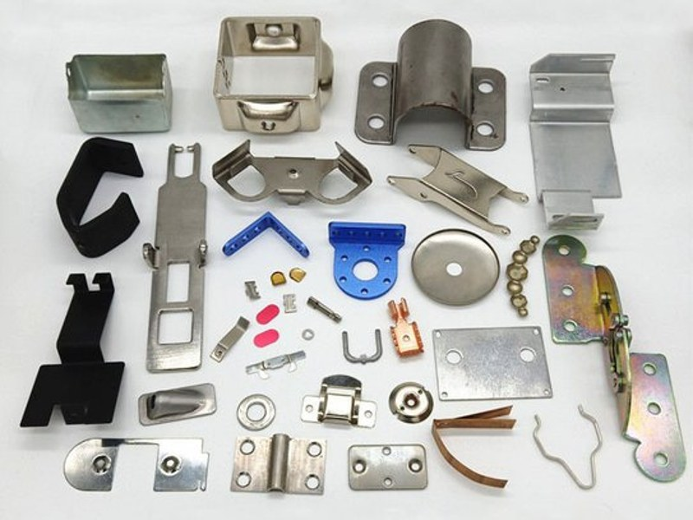  Stamped and formed metal parts | 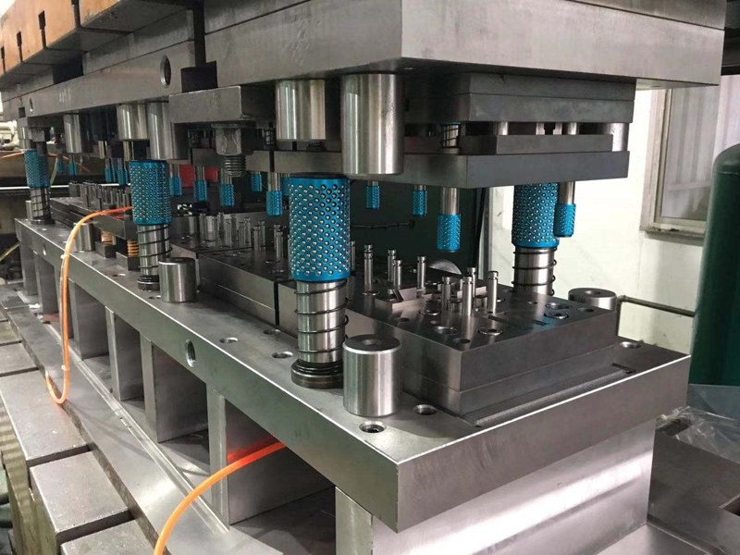  Progressive stamping die
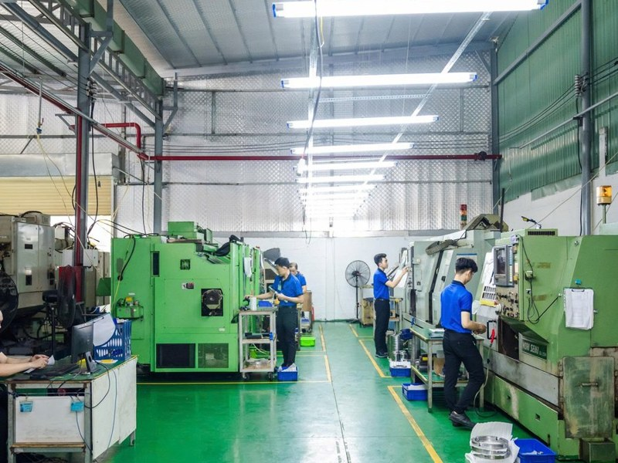  CNC machining at a partner source | 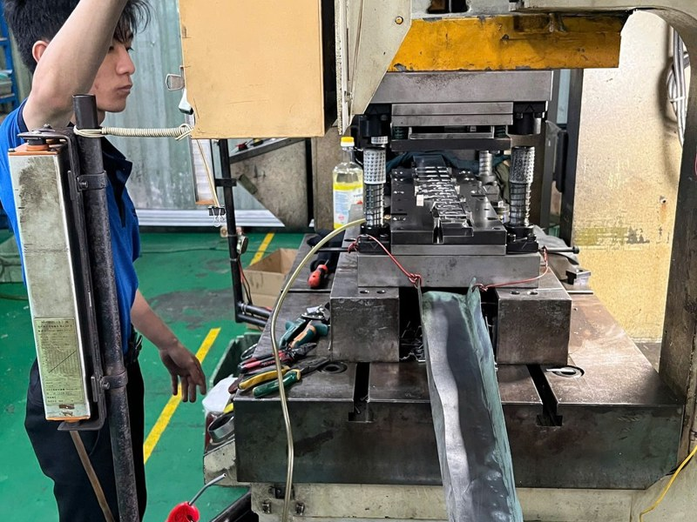  Press line production
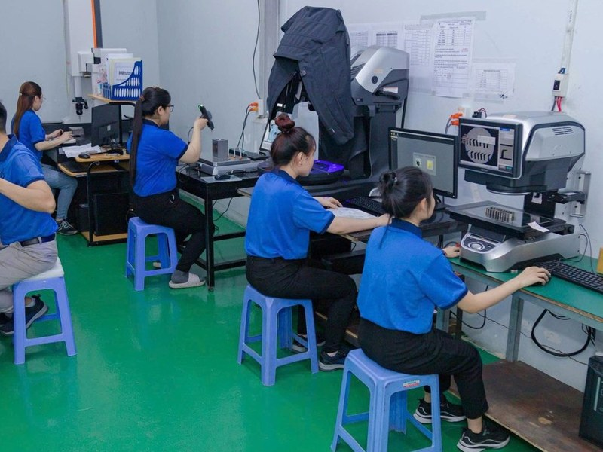  Dimensional inspection | 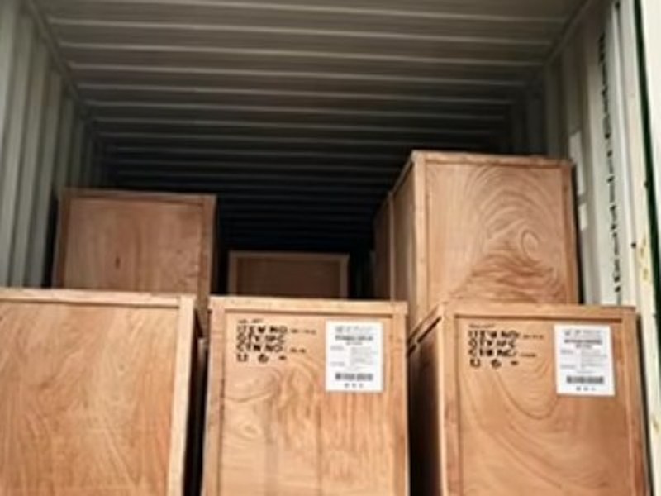  Export packing in wooden crates
Photos show parts and facilities at manufacturing sources in ALG’s partner network. ALG does not operate a factory.

