


LIGHTING CONTROLLER CABINET

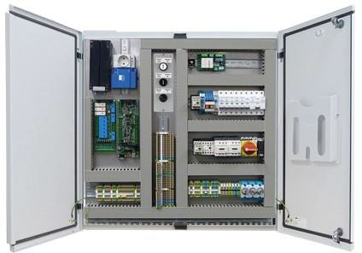 | 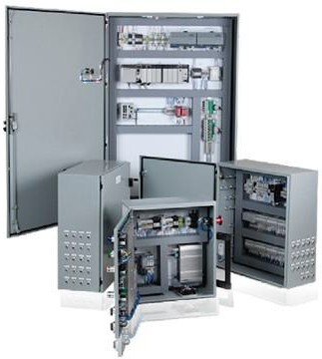 | 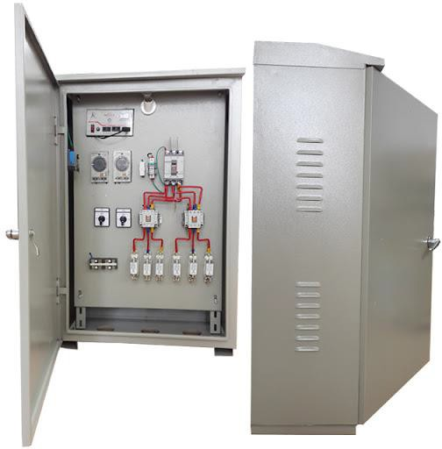
PLC lighting control cabinet |  | Timer lighting control cabinet
SMART CAMERA CONTROLLER

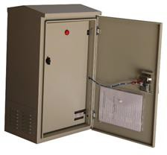 | 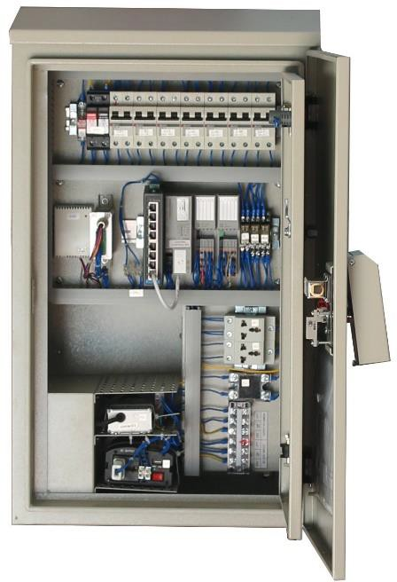 | 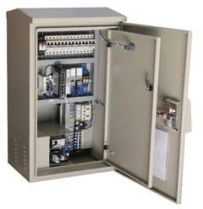
Smart Camera Controller
WATER ELECTRONIC MONITORING
Smart Water Monitor

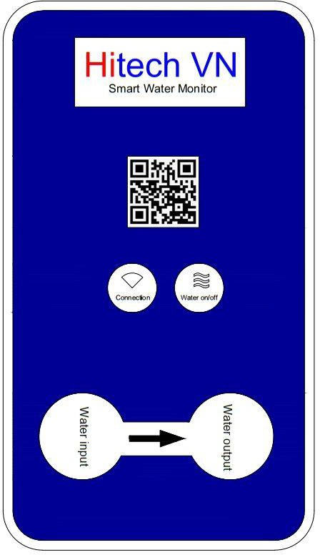

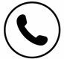
export.hitech-vn.com
|
sales@hitech-vn.com
|
+84 24 73018681

