


POWER TRANSMISSION POLES

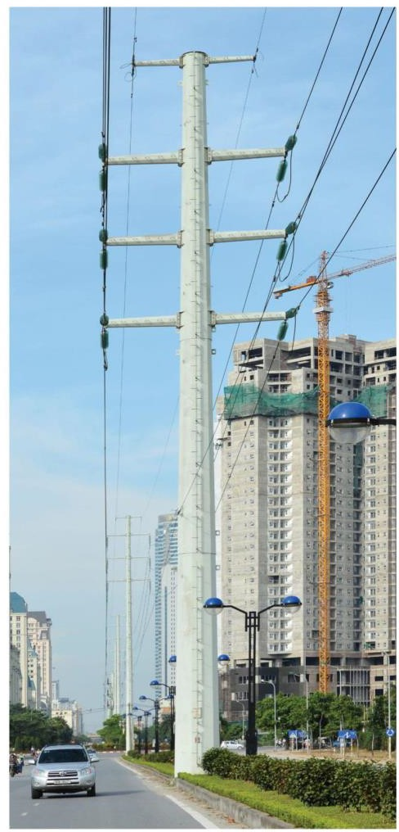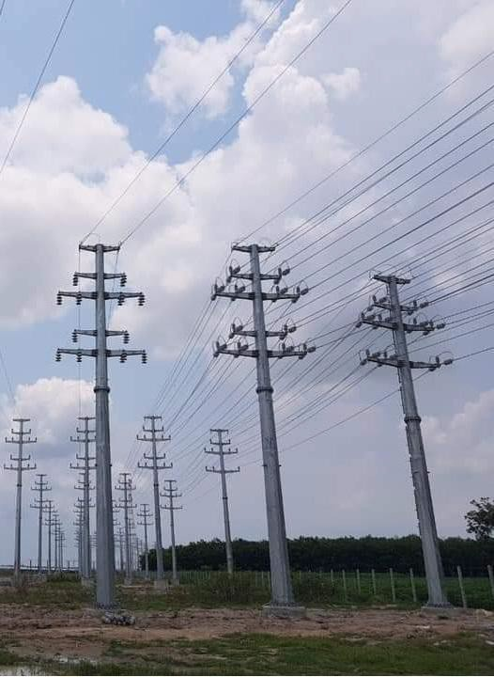
Note: The dimensions and mounting fixtures are changed and manufactured on customer’s request.

TELECOM COMMUNICATION POLES

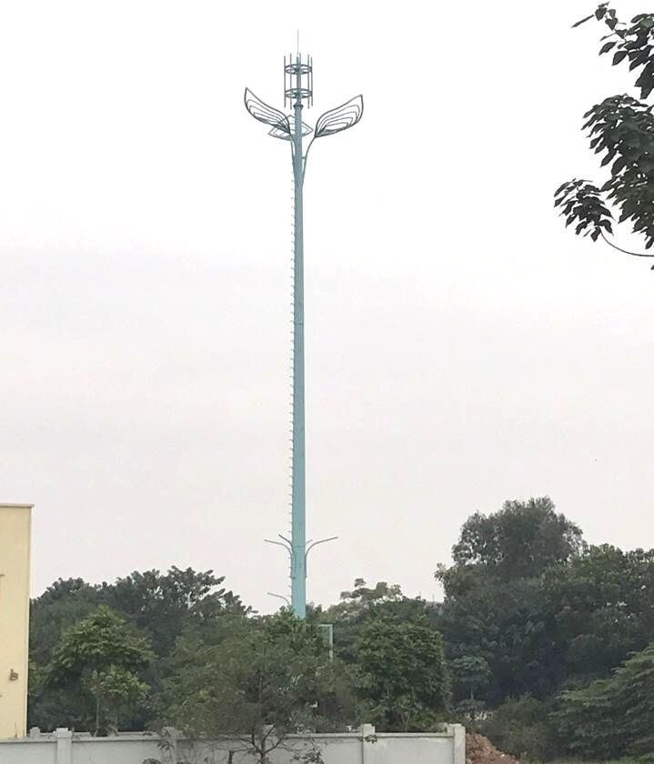 | 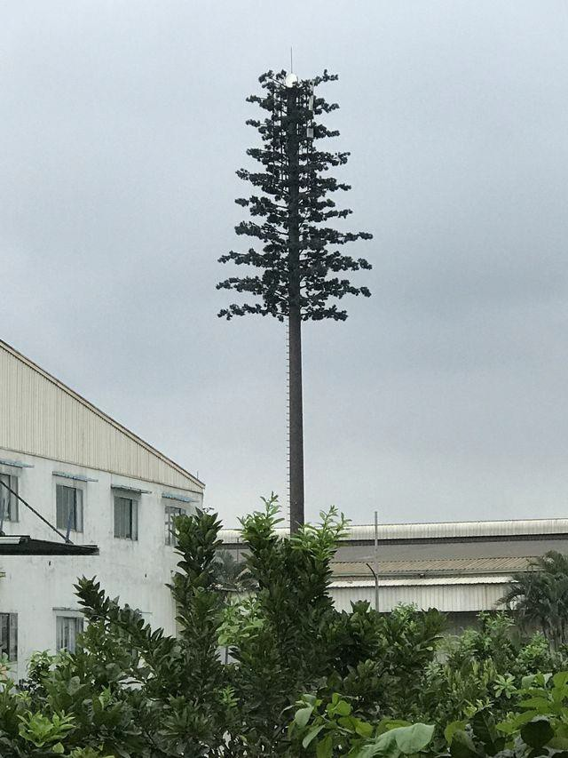 | 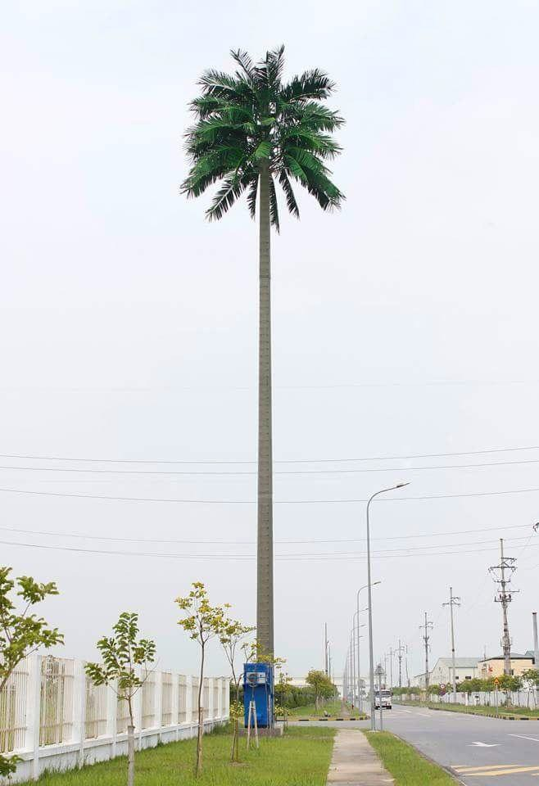
Smart Camera Controller | Camouflage Pine Tree Cell Tower | Camouflage Coconut Tree Cell Tower


export.hitech-vn.com
|
sales@hitech-vn.com
|
+84 24 73018681

