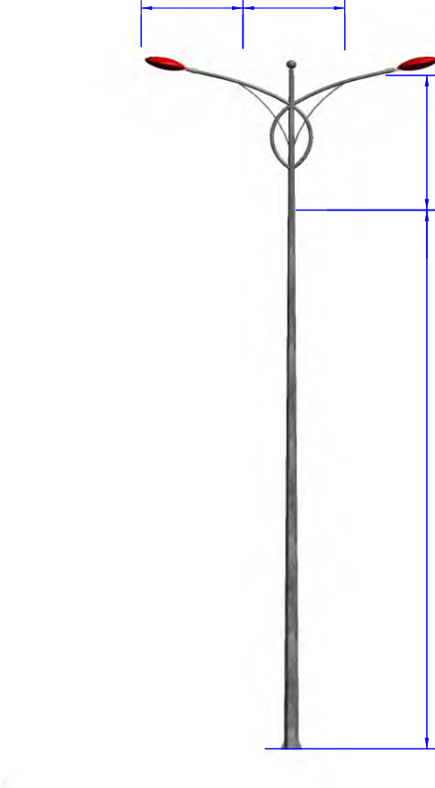
1500 1500
STANDARD ARM
2000

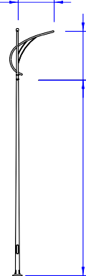
1500
BG10-D78/CKB-01
H
2000

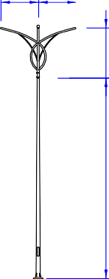
1500 1500
CD-05
CD-04
CD-03
CD-02
CD-06
CD-01
HITECH VIETNAM
2000
2000
2000
2000
2000
2000

1500

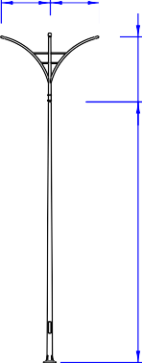
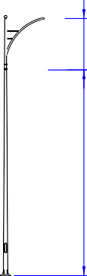1500 1500
2000
H

1500

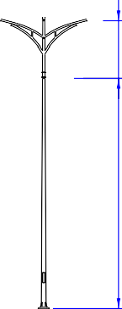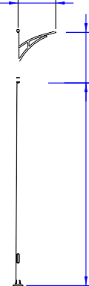1500 1500

1500

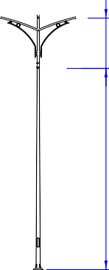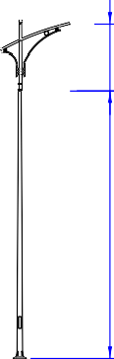1500 1500
H
2000

1500

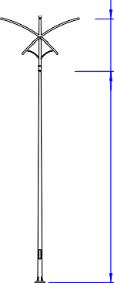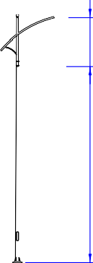1500 1500
H
2000

1500

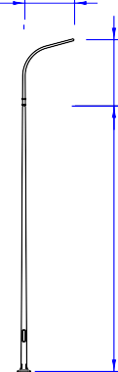
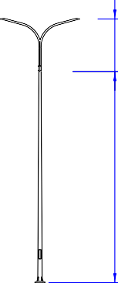1500 1500
H
2000
2000
H

H

CK-02 | CK-03 | CK-04 | CK-05

Note: Can produce according to customer's request.
CK-06
CK-01
H
H
H
H
H
H

STEEL LIGHTING POLE WITH CAST-IRON BASEPLATE FOR DECORATING
H

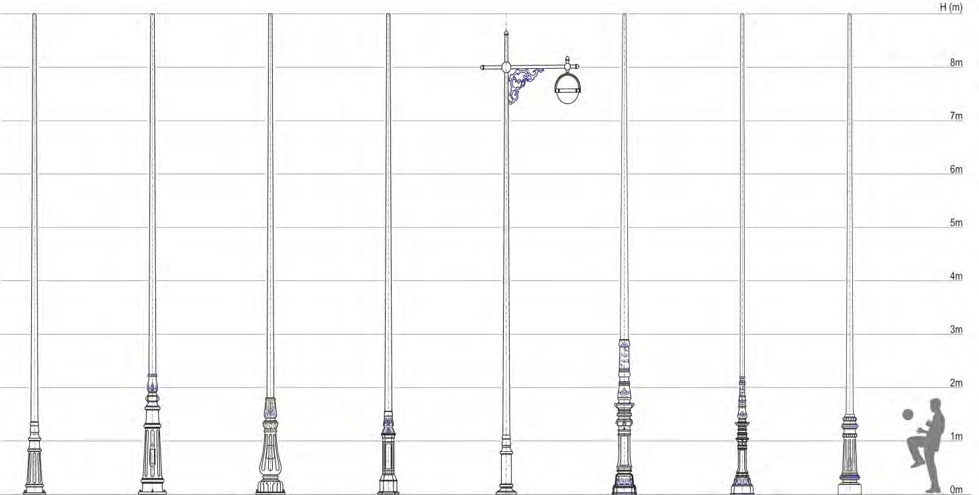

DP-01 DP-01B DC-03B DP-05 DP-09 DP-17 DP-18 DP-19

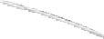1500 1500
2000

Note: Can produce according to customer's request.
HITECH VIETNAM
TC10-D78/CKT-04/DP-01

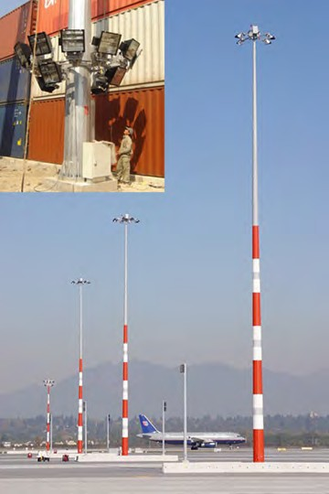
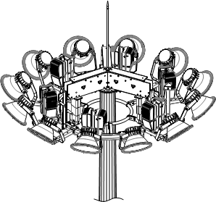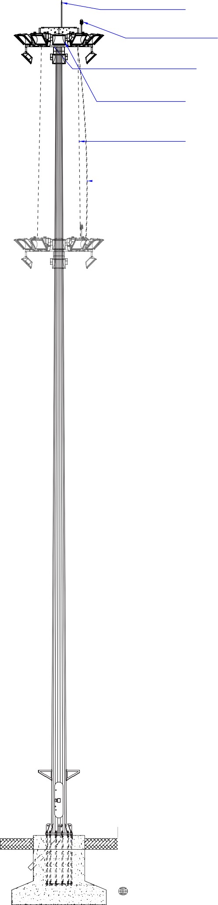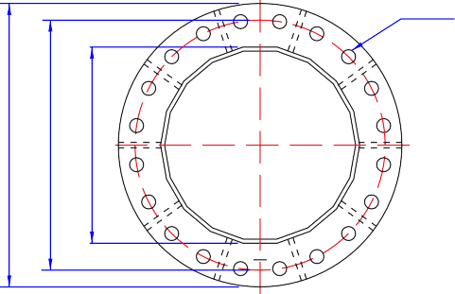
g
FLOODLIGHT POLE
STEEL LIGHTING POLE
Lightning rod

Signal lights Portable frame
Floodlight
Steel cable
Electric cable
nxØB
Base plate
Floodlight Pole
export.hitech-vn.com
|
sales@hitech-vn.com
M N
D2

Items | Specifications Design specifications of anchor
Items | H  (m) | T  (mm) | D1  (mm) | D2  (mm) | M  (mm) | N  (mm) | nxØB | Pressure  (KN) | Cuttin  force  (KN) | Momen (KN.m)
NH20 | 20 | 5/5 | 260 | 610 | 850 | 750 | 20X36 | 22.4 | 19.81 | 256.45
NH25 | 25 | 5/6/6 | 260 | 600 | 850 | 750 | 20X36 | 28.16 | 23.08 | 367.43
NH30 | 30 | 5/6/8 | 260 | 673 | 900 | 800 | 20X36 | 36.80 | 28.25 | 509.71
NH35 | 35 | 6/6/8/8 | 260 | 728 | 1000 | 900 | 20X36 | 47.08 | 33.24 | 676.06
NH40 | 40 | 6/6/8/8 | 260 | 840 | 1050 | 960 | 24X36 | 57.22 | 40.59 | 894.05
NH45 | 45 | 6/6/8/8/10 | 260 | 919 | 1150 | 1050 | 24X42 | 74.42 | 47.39 | 1131.21

Note: Can produce according to customer's request.
HITECH VIETNAM

 |  +84 24 73018681

