
export.hitech-vn.com
|
sales@hitech-vn.com
|
+84 24 73018681

BOLLARD

BL20 | 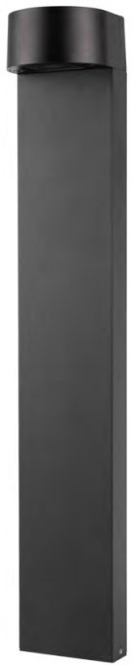  BL20
BL20 | 7W W100*H600mm

BL04 | 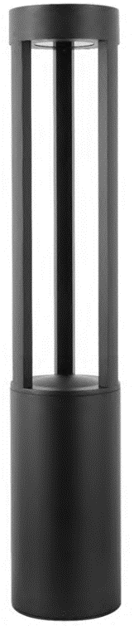  BL04
BL04 | 12W/24W D150*H300/800-4000mm

BL32 | 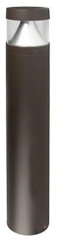  BL 32
BL32 | 12W - 15W D160*H600-900mm

BL08 | 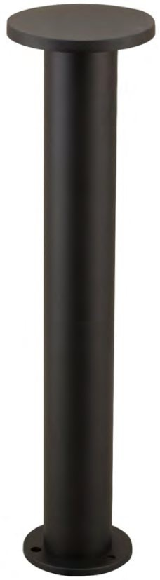  BL08B
BL08 | 12W D120*H600mm





FLOODLIGHT

Cinnamon BL-FL02 | 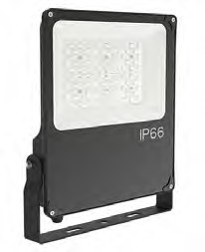  BL-FL02A | 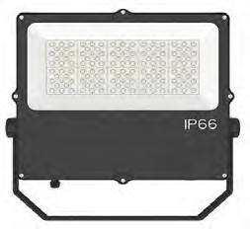  BL-FL02B | 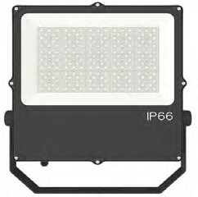  BL-FL02C | 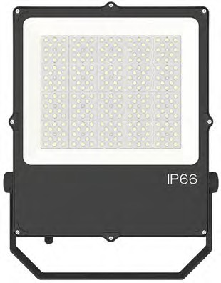  BL-FL02D | 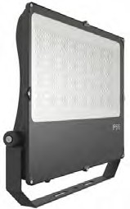  BL-FL02E
Cinnamon BL-FL02 | 30W-50W L274*W299*H52mm | 60W-100W L394*W325*H57mm | 110W-150W L392*W376*H57mm | 160W-200W L392*W427*H59mm | 210W-300W L546*W447*H65mm

Cypress BL-FL04 | 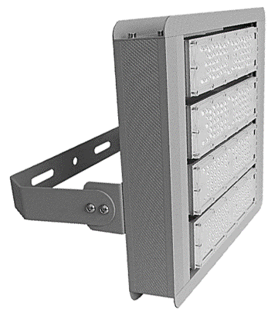  BL-FL04 4M | 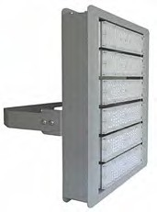  BL-FL04 6M | 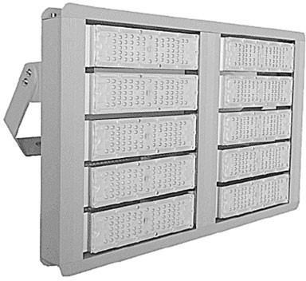  BL-FL04 10M | 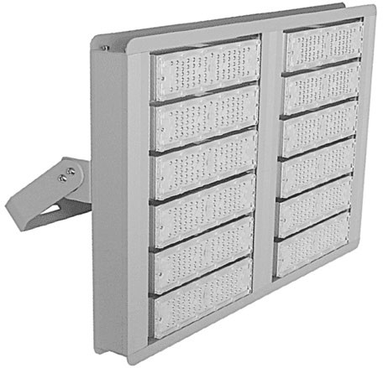  BL-FL04 12M | 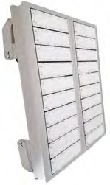  BL-FL04 20M
Cypress BL-FL04 | 150W-200W L371*W355*H72mm | 250W-300W L531*W355*H72mm | 400W-500W L680*W371*H72mm | 500W-600W L680*W451*H72mm | 800W-1000W L851*W680*H72mm

Thyme BL-FL05 | 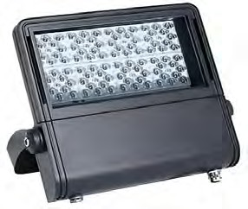  BL-FL05A | 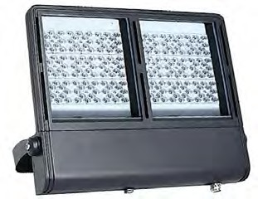  BL-FL05B | BL-FL05C
Thyme BL-FL05 | 30W-60W L292*W255*H53mm | 70W-120W L392*W277*H53mm | 130W-200W L395*W381*H60mm

Rosemary BL-FL08 | 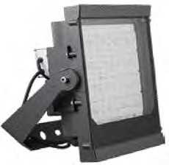  BL-FL08A | 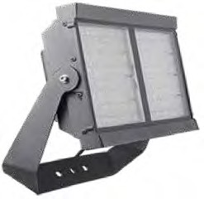  BL-FL08B | 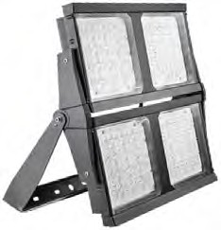  BL-FL08C
Rosemary BL-FL08 | 100W-300W L320*W353*H157mm | 310W-600W L614*W326*H157mm | 610W-1200W L663*W666*H157mm

Daddle BL-FL10 | 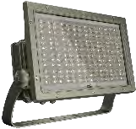  BL-FL10A | 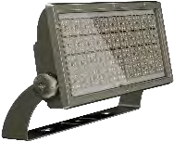  BL-FL10B | 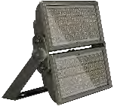  BL-FL10C
Daddle BL-FL10 | 150W-300W L285*W445*H150mm | 320W-600W L306*W740*H175mm | 1000W-1200W L599*W740*H175mm

Step BL-FL11 | 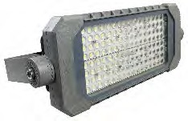  BL-FL11A | 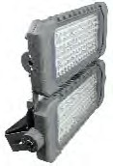  BL-FL11B | 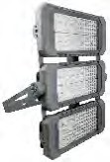  BL-FL11C | 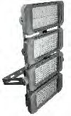  BL-FL11D | 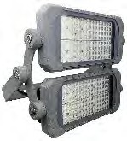  BL-FL11B AJ
Step BL-FL11 | 100W-120W L205*W340*100Hmm | 200W-240W L355*W340*100Hmm | 300W-360W L510*W340*100Hmm | 400W-480W L660*W340*100Hmm | 200W-240W L285*W357*100Hmm
 | 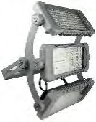  BL-FL11C AJ | 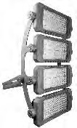  BL-FL11D AJ
 | 300W-360W L435*W357*130Hmm | 400W-480W L615*W357*135Hmm
Rosewood BL-FL06 | 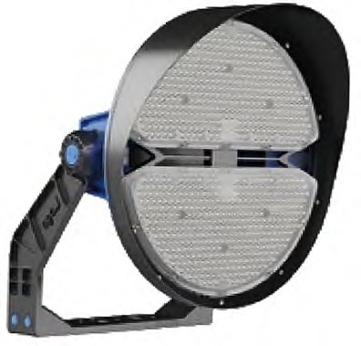  BL-FL06A | BL-FL06B
Rosewood BL-FL06 | 300W-500W D493*H421mm | 600W-1000W D586*H511mm

Oleander BL-FL09 | 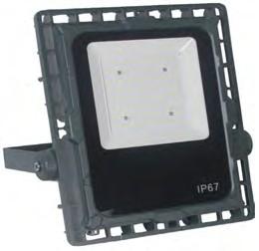  BL-FL09A | BL-FL09B
Oleander BL-FL09 | 50W-70W L306*W290*H65mm | 80W-100W L350*W315*H65mm



export.hitech-vn.com | sales@hitech-vn.com | +84 24 73018681


STREET LIGHT

Ash BL-STR04 | 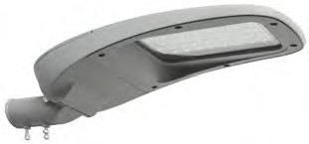  BL-STR04A (OUT) | BL-STR04B (OUT) | BL-STR04C (OUT) | BL-STR04D (OUT) | 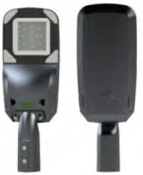  BL-STR04A (IN)
Ash BL-STR04 | 30W-50W L507*W210*H143mm | 60W-90W L616*W259*H186mm | 100W-120W L676*W303*H186mm | 120W-180W L915*W365*H198mm | 30W L520*W200*H100mm
 | 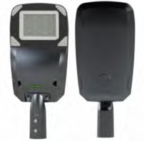  BL-STR04B (IN) | 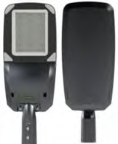  BL-STR04C (IN) | 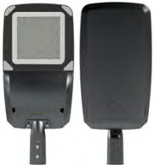  BL-STR04D (IN) | 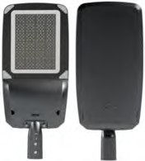  BL-STR04E (IN)
 | 50W-60W L620*W272*H108mm | 70W-120W L720*W272*H108mm | 130W-160W L750*W333*H115mm | 170W-240W L850*W333*H115mm

Palm BL-STR05 | 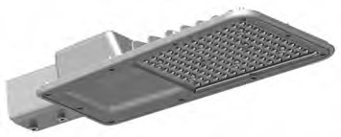  BL-STR05A | 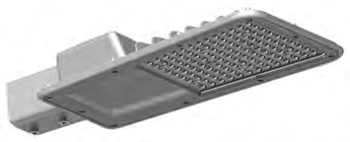  BL-STR05B | BL-STR05C
Palm BL-STR05 | 30W-50W L380*W242*H95mm | 60W-100W L480*W271*H95mm | 110W-150W L600*W342*H95mm

Maple BL-STR06 | 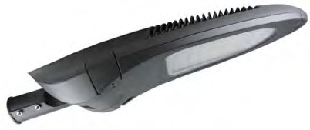  BL-STR06A | BL-STR06B | BL-STR06C
Maple BL-STR06 | 30W-60W L691*W305*H135mm | 70W-120W L691*W305*H135mm | 140W-180W L830*W385*H172mm

Willow BL-STR10 | 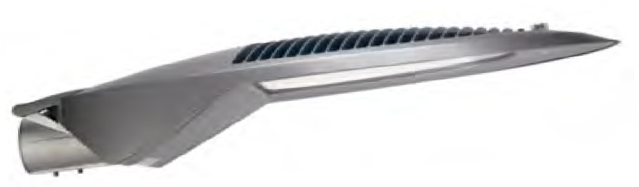  BL-STR10
Willow BL-STR10 | 100W-180W L870*W370*H170mm

Elm BL-STR09 | 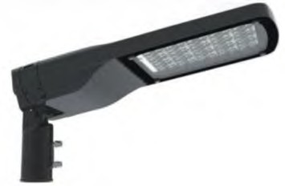  40W-50W | 60W-90W | 100W-150W
Elm BL-STR09 | BL-STR09A  L577*W233*H103mm | BL-STR09B  L627*W271*H103mm | BL-STR09C  L786*W301*H103mm

ZELUS HT-ZELUS LT | 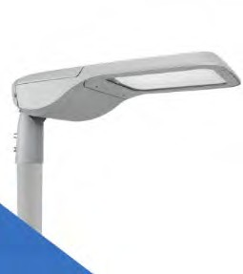  HT-ZELUS LT
ZELUS HT-ZELUS LT | 25W - 245W

Pine BL-STR11 | 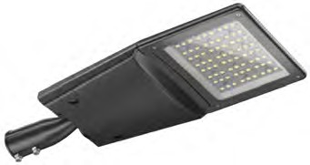  BL-STR11A (in) | BL-STR11B (in) | BL-STR11C (in)
Pine BL-STR11 | 30W-70W L570*W230*H108mm | 80W-120W L679*W288*H111mm | 140W-200W L752*W307*H112mm

Hazel BL-STR08 | 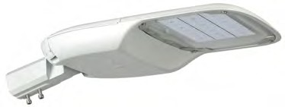  BL-STR08A
Hazel BL-STR08 | 40W-100W L555*W330*H108mm

Lime BL-STR15 | 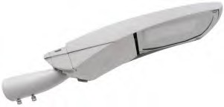  BL-STR15A (IN) | BL-STR15B (IN) | BL-STR15C (IN)
Lime BL-STR15 | 50W-100W L646*W256*H129mm | 100W-150W L791*W305*H129mm | 160W-300W L844*W361*H130mm

Hazel BL-STR08 | 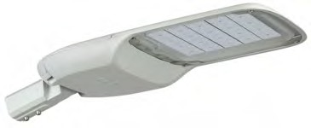  BL-STR08B
Hazel BL-STR08 | 110W-180W L655*W330*H108mm



export.hitech-vn.com | sales@hitech-vn.com | +84 24 73018681

Cedarwood BL-STR18 | 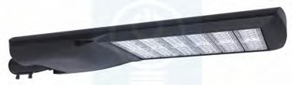  BL-STR18A (OUT) | BL-STR18B (OUT) | BL-STR18C (OUT) | BL-STR18D (OUT) | BL-STR15E (OUT)
Cedarwood BL-STR18 | 50W-100W  L639*W371*H158mm | 110W-150W  L719*W371*H158mm | 160W-200W  L799*W371*H158mm | 210W-250W  L879*W371*H158mm | 260W-300W  L959*W371*H158mm
 | 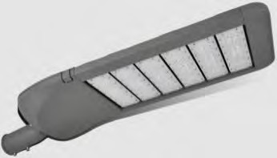  BL-STR15A (GEN2) | BL-STR15B (GEN2)
 | 50W-100W L650*W350*H135mm | 110W-150W L730*W350*H135mm

export.hitech-vn.com | sales@hitech-vn.com | +84 24 73018681

POSTOP (BL-PT)

Monstella BL-PT01 | 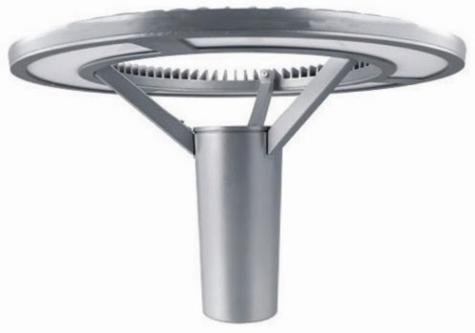  BL-PT01
Monstella BL-PT01 | 40W-70W D600*H391mm

Hawthorn BL-PT02 | 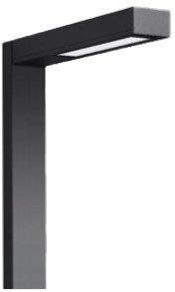  BL-PT02A | 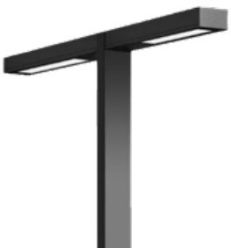  BL-PT02B
Hawthorn BL-PT02 | 40W L911*W150*H90mm | 2*40W L1900*W150*H90mm

Peacockii BL-PT03 | 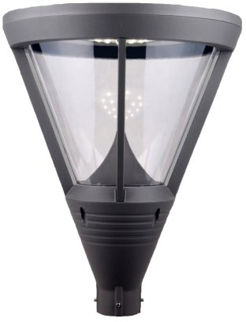  BL-PT03
Peacockii BL-PT03 | 20W-80W D480*H620mm

Stapelia BL-PT09 | 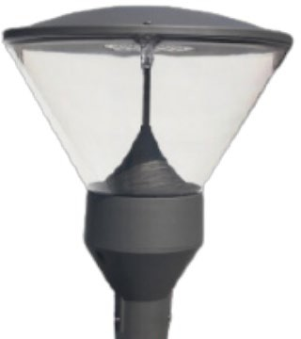  BL-PT09A | 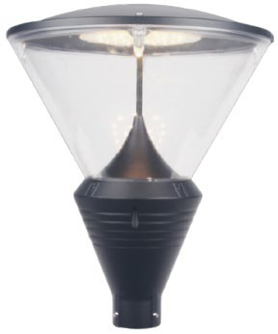  BL-PT09B
Stapelia BL-PT09 | 16W-80W D460*H595mm | 16W-80W D460*H595mm

Hoya BL-PT07 | 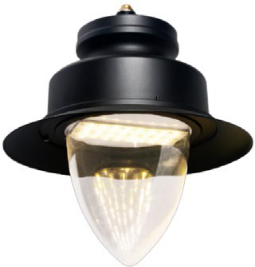  BL-PT07
Hoya BL-PT07 | 16W-80W  D600*H655mm

Iboga BL-PT11 | 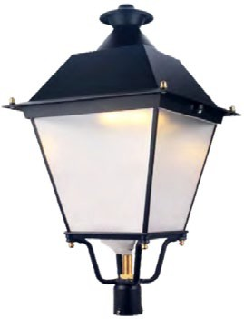  BL-PT11
Iboga BL-PT11 | 10W-100W  W422*H845mm

HT - PLAMOON | 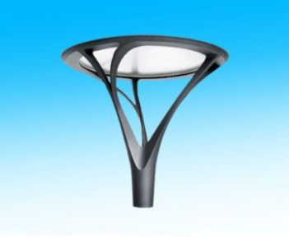
HT - PLAMOON | 30W-100W D600*H610mm

HT - MOONY | 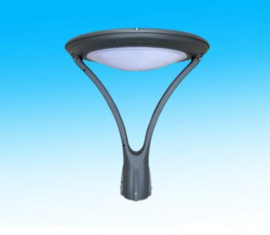
HT - MOONY | 20W-80W D520*H560mm

HT - NICELUX - A | 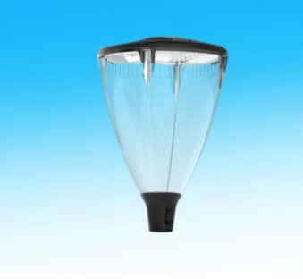
HT - NICELUX - A | 30W-100W D402*H655mm

HT - KENTA | 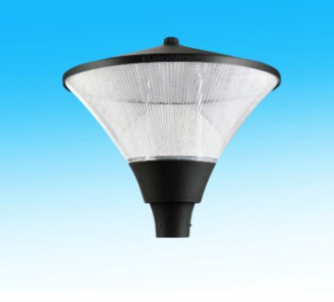
HT - KENTA | 30W-100W D592*H524mm

Proceca BL-PT12 | 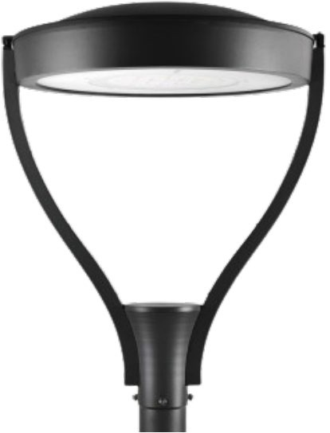  BL-PT12
Proceca BL-PT12 | 20W-60W D620*H800mm

Alstonia BL-PT08 | 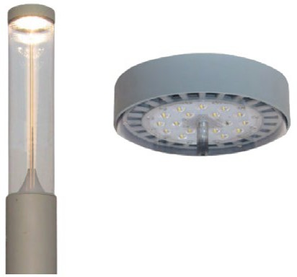  BL-PT08
Alstonia BL-PT08 | 20W-50W D220*H819mm

Speciosa BL-PT13 | 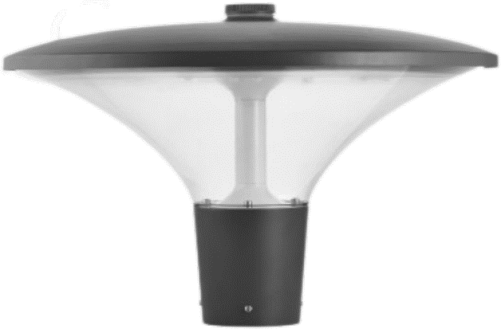  BL-PT13
Speciosa BL-PT13 | 20W-60W D566*H400mm

export.hitech-vn.com
|
sales@hitech-vn.com
|
+84 24 73018681


SPOT LIGHT (FCD)

FCD01 | 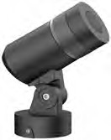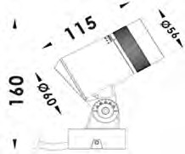 | 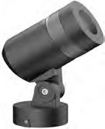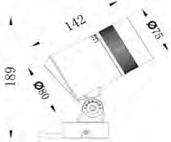 | 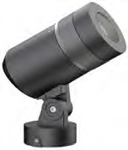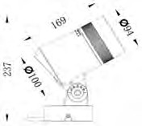 | 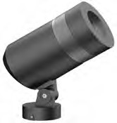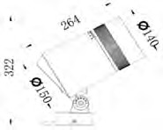
FCD01 | BL-FCD01A 8W; D54mm | BL-FCD01B 15W; D75mm | BL-FCD01C 25W; D94mm | BL-FCD01D 45W; D140mm

FCD02 | 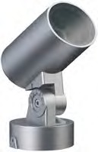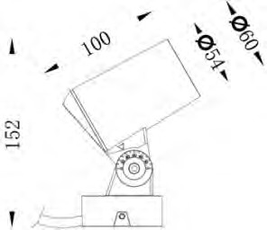 | 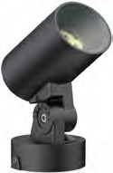 | 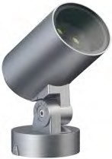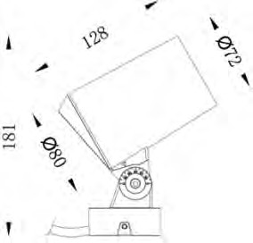 | 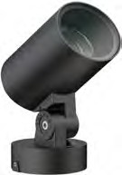 | 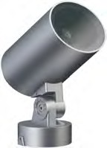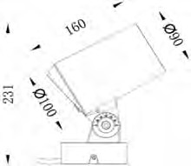
FCD02 | BL-FCD02AA 3*3W; D54mm | BL-FCD02AB 1*8W; D54mm | BL-FCD02BA 4*3W; D72mm | BL-FCD02BB 1*15W; D140mm | BL-FCD02CA 6*4W; D90mm
 | 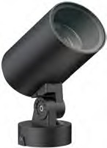 | 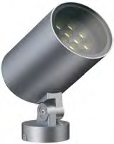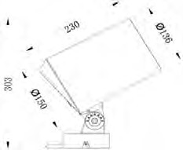 | 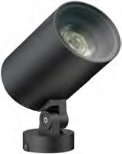
 | BL-FCD02CB 25W; D90mm | BL-FCD02DA 12*4W; D136mm | BL-FCD02DB 1*50W; D136mm

FCD03 | 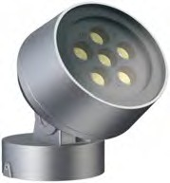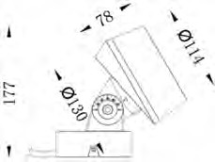 | 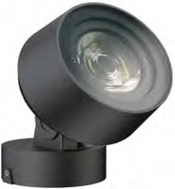 | 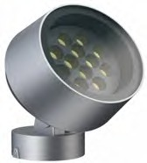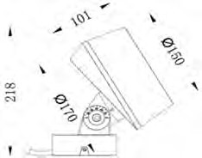 | 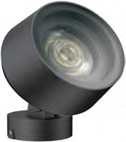 | 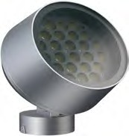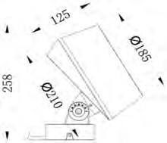
FCD03 | BL-FCD03AA 6*3W; D114mm | BL-FCD03AB 1*18W; D114mm | BL-FCD03BA 12*3W; D150mm | BL-FCD03AA 1*30W; D150mm | BL-FCD03CA 24*2W; D185mm
 | 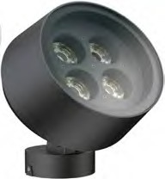 | 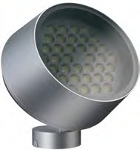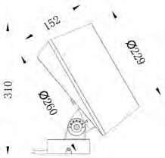 | 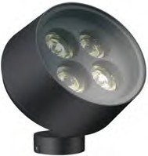
 | BL-FCD03CB 4*10W; D185mm | BL-FCD03DA 36*2W; D229mm | BL-FCD03DB 4*15W; D229mm

FCD04 | 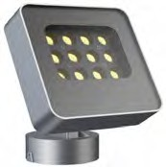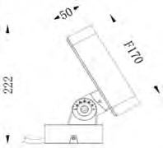 | 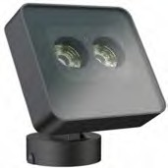 | 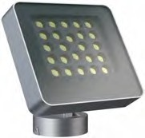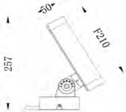 | 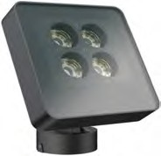 | 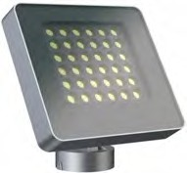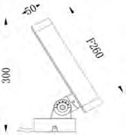
FCD04 | BL-FCD04AA 12*2W; F170mm | BL-FCD04AB 2*12W; F170mm | BL-FCD04BA 24*1.5W; F210mm | BL-FCD04BB 4*9W; F210mm | BL-FCD04CA 36*1.6W; F260mm
 | 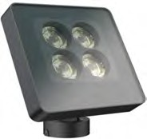
 | BL-FCD04CB 4*14W; F260mm

FCD06 | 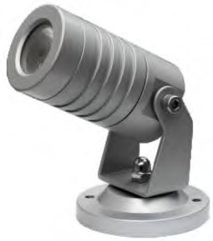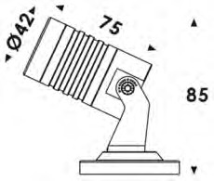 | 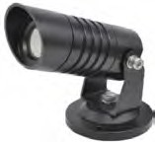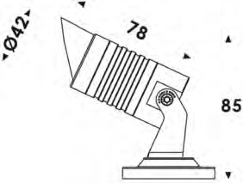 | 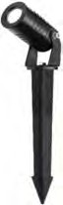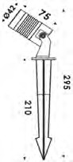 | 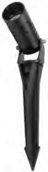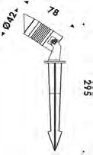 | 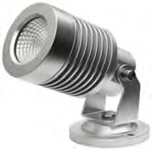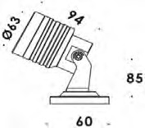
FCD06 | BL-FCD06AA 1*2W; (D42*L75mm) | BL-FCD06AB 1*2W; (D42*L75mm) | BL-FCD06AC 1*2W; (D42*L75mm) | BL-FCD06AD 1*2W; (D42*L75mm) | BL-FCD06BA 6W; (D62*L133mm)




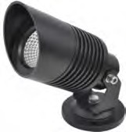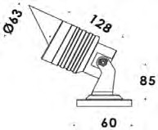 | 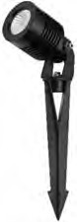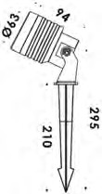 | 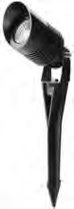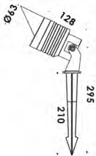 | 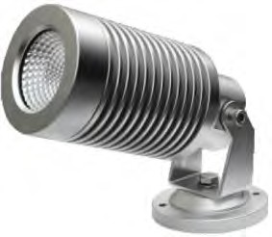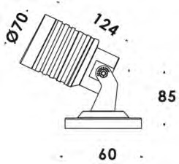 | 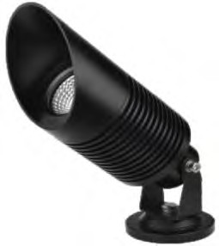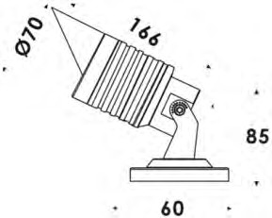
BL-FCD06BA 6W; (D62*L133mm) | BL-FCD06BA 6W; (D62*L133mm) | BL-FCD06BA 6W; (D62*L133mm) | BL-FCD06CA 12W; (D70*L150mm) | BL-FCD06CA 12W; (D70*L150mm)
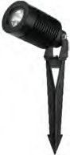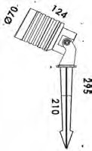 | 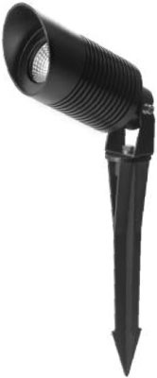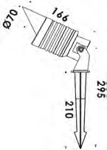
BL-FCD06CA 12W; (D70*L150mm) | BL-FCD06CA 12W; (D70*L150mm)

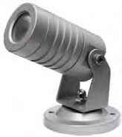 | 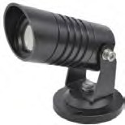 | 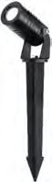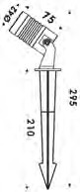 | 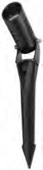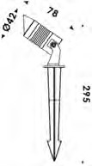 | 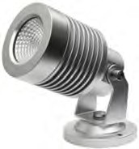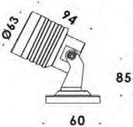
BL-FCD06AA-G2 1*2W; (D42*L75mm) | BL-FCD06AB-G2 1*2W; (D42*L75mm) | BL-FCD06AC-G2 1*2W; (D42*L75mm) | BL-FCD06AD-G2 1*2W; (D42*L75mm) | BL-FCD06BA-G2 6W; (D62*L133mm)
 |  |  |  | 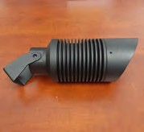
BL-FCD06BA-G2 6W; (D62*L133mm) | BL-FCD06BA-G2 6W; (D62*L133mm) | BL-FCD06BA-G2 6W; (D62*L133mm) | BL-FCD06CA-G2 12W; (D70*L150mm) | BL-FCD06CA-G2 12W; (D70*L150mm)
BL-FCD06CA-G2 12W; (D70*L150mm) | BL-FCD06CA-G2 12W; (D70*L150mm)

FCD08 | 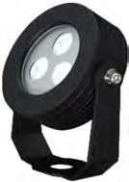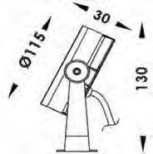 | 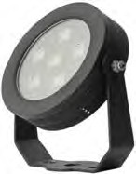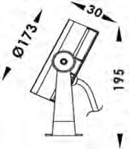
FCD08 | BL-FCD08A 3*2W; (D115*L30mm) | BL-FCD08B 6*2W; (D173*L30mm)

export.hitech-vn.com | sales@hitech-vn.com | +84 24 73018681

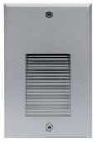

STEPLIGHT (ST)

Ramillette ST01 | 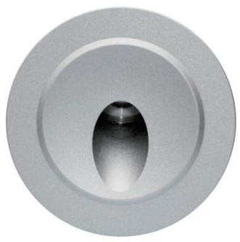  ST01A | 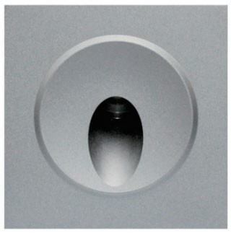  ST01AS | 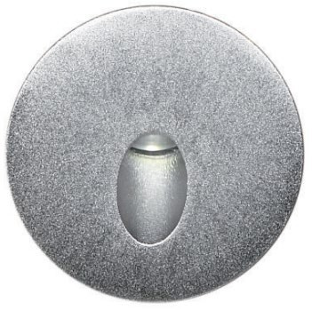  ST01B | 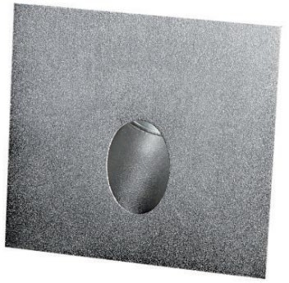  ST01BS
Ramillette ST01 | 1*3W D78.5*H53mm MS: D71*L76mm | 1*3W L78.5*W78.5*H53mm MS: D71*L76mm | 1*3W D78.5*H53mm MS: D71*L76mm | 1*3W L78.5*W78.5*H53mm MS: D71*L76mm

Cocoon Plant ST02 | 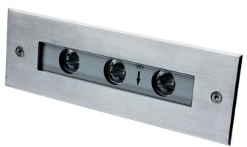  ST02A | 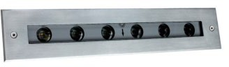  ST02B
Cocoon Plant ST02 | 3*2W L195*W63*H65mm MS: L180*W58*H90mm | 6*2W L328*W63*H65mm MS: L313*W58*H90mm

Scaposus ST03 | 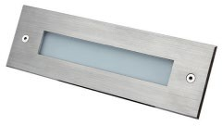  ST03A | 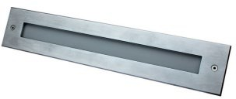  ST03B
Scaposus ST03 | W L195*W63*H65mm  MS: L180*W58*H90mm | W L328*W63*H65mm  MS: L313*W58*H90mm

Vertical ST04 |  | 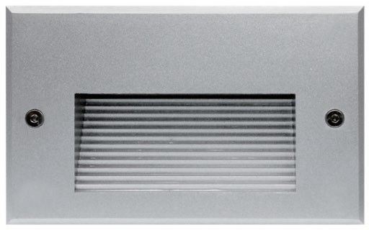 | 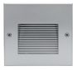 | 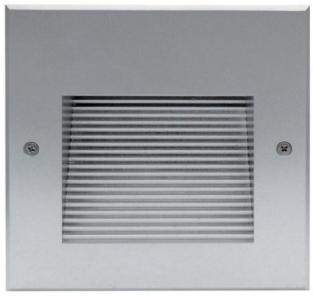
 | ST04A | ST04B | ST04C | ST04D
 |  |  | 2W | 2W
 | 2W | 3W | L120*W120*H75mm | L160*W160*H79mm
 | L106*W171*H65mm | L171*W106*H65mm | MS: | MS:
 | MS: L98*W160*H85mm | MS: L160*W86*H85mm | L112*W112*H95mm | L152*W152*H116mm

Candle Plant ST06 | 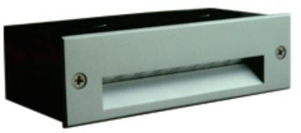  ST06A | 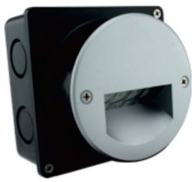  ST06B | 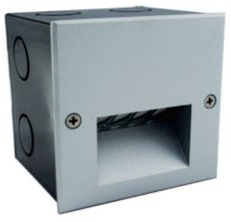  ST06C
Candle Plant ST06 | 2W L145*W45*H68mm | W L100*W100*H80mm | W  L95*W95*H80mm
Swizzle Sticks ST07 | 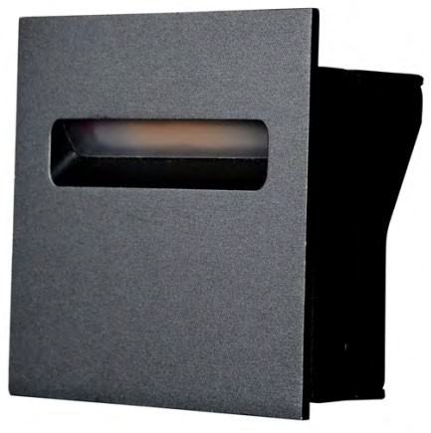  ST07A
Swizzle Sticks ST07 | 3W  L88*W86*H42mm

Citriformis ST08 | 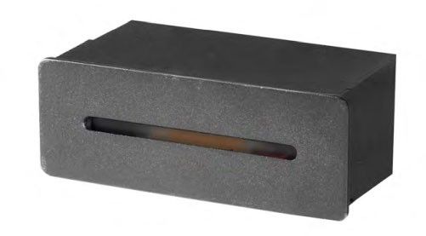  ST08A
Citriformis ST08 | 3W L110*W40mm  L102*W39*H50mm

Cylindricus ST09 | 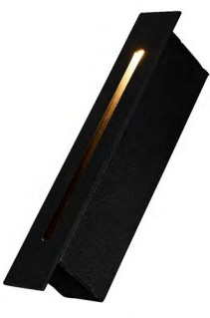  ST09A
Cylindricus ST09 | 3W L183*W30*H35mm

Fizzle ST10 | 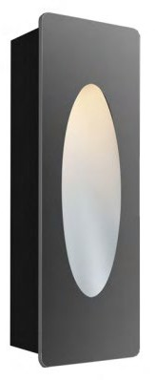  ST10A
Fizzle ST10 | 3W L108*W38*H53mm

export.hitech-vn.com | sales@hitech-vn.com | +84 24 73018681
_______
__________

HIGHBAY LIGHT

Oak  BL-HB01 (out) BL-HB-UFO-A (in) | 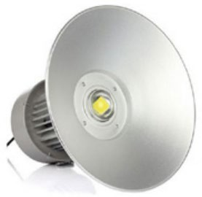  BL-HB01A (out) | BL-HB01B (out) | 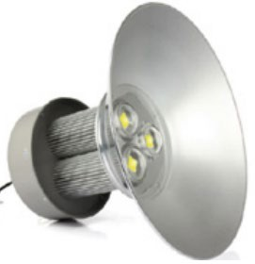  BL-HB01C (out) | 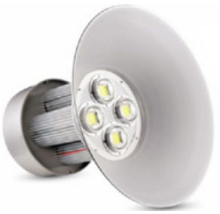  BL-HB01D (out) | 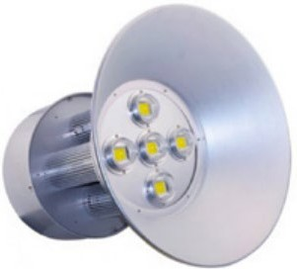  BL-HB01E (out)
Oak  BL-HB01 (out) BL-HB-UFO-A (in) | 40W-60W W410*H1(270)*H2(70) | 70W-100W W410*H1(360)*H2(160) | 110W-150W W490*H1(450)*H2(210) | 160W-200W W490*H1(420)*H2(180) | 210W-250W W560*H1(450)*H2(210)
 | 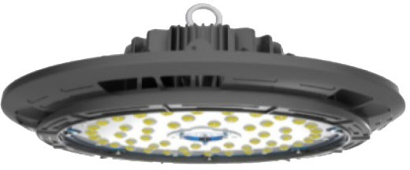  BL-HB-UFO-A1 (in) | BL-HB-UFO-A2 (in) | BL-HB-UFO-A3 (in) | BL-HB-UFO-A4 (in)
 | 40W-50W  D250mm | 60W-100W  D310mm | 110W-120W  D350mm | 130W-200W  D380mm

Fir  BL-HB-UFO-B | 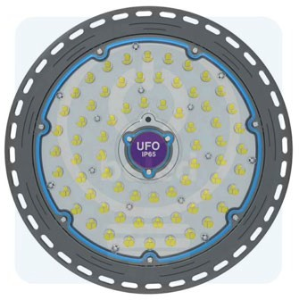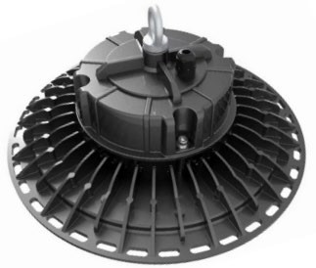  BL-HB-UFO-B1 | BL-HB-UFO-B2 | 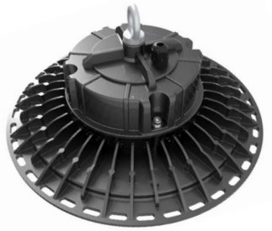  BL-HB-UFO-B3
Fir  BL-HB-UFO-B | 70W-100W W277*H41.5mm | 110W-150W W310*H41.5mm | 160W-240W W350*H40.2mm

Redwood BL-HB-UFO-C | 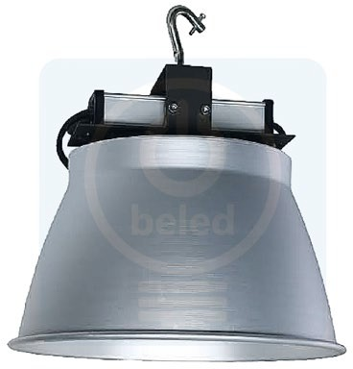  BL-HB-UFO-C1 | 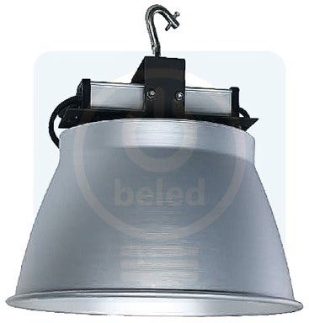  BL-HB-UFO-C2
Redwood BL-HB-UFO-C | 50W-100W W370*H390mm | 110W-160W W510*H459mm

Vine  BL-HB-UFO-D | 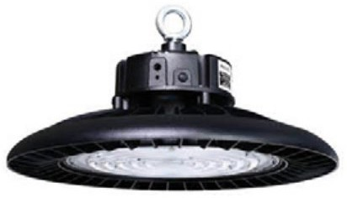  BL-HB-UFO-D1 (out) | BL-HB-UFO-D2 (out) | 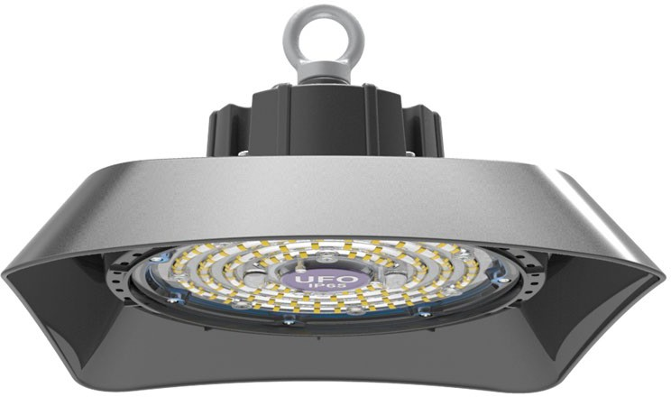  BL-HB-UFO-D1 (in) | BL-HB-UFO-D2 (in) | BL-HB-UFO-D3 (in)
Vine  BL-HB-UFO-D | 70W-100W W275*H190mm | 110W-200W W350*H200mm | 50W-100W W253*L253mm | 100W-150W W315*L315mm | 150W-200W W335*L335mm

export.hitech-vn.com | sales@hitech-vn.com | +84 24 73018681



UNDERGROUND LIGHT (UG)

Aloe UG01 | 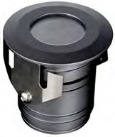  UG01A | 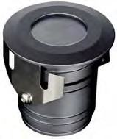  UG01B | 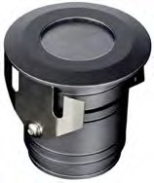  UG01C
Aloe UG01 | 3W-5W D61*H100mm | 7W D70*H105mm | 12W D79*H115mm
Hedgehog UG03 | 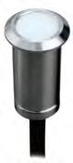  UG03A | 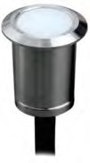  UG03B
Hedgehog UG03 | 1W  D20*H45mm Cutout: D15mm | 1W  D30*H45mm Cutout: D24mm

Bishop cap UG04 | 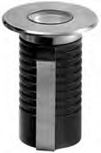  UG04 | 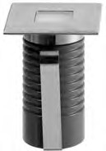  UG04S
Bishop cap UG04 | 1W - Cutout D:50mm D38*H65mm  MS: D50*H83mm | 1W - Cutout D:50mm F38*H65mm  MS: D50*H83mm

Pine come UG05 | 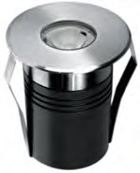  UG05A | 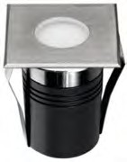  UG05AS
Pine come UG05 | 3W - Cutout D80mm D55*H82mm  MS: D80*H115mm | 3W - Cutout D80mm F55*H82mm  MS: D80*H115mm

Angle Wing UG06 | 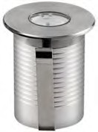  UG06A | 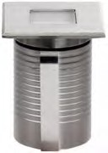  UG06AS
Angle Wing UG06 | 3W - Cutout D67mm D45*H65mm  MS: D67*H83mm | 3W - Cutout D67mm F45*H65mm  MS: D67*H83mm

Dwarychin UG07 | 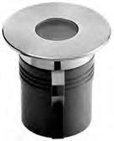  UG07A | 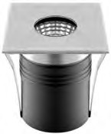  UG07AS
Dwarychin UG07 | 6W - Cutout D136mm D70*H82mm  MS: D136*H133mm | 6W - Cutout D136mm F70*H82mm  MS: D136*H133mm

Paper spin UG08 | 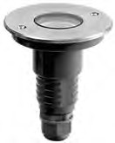  UG08A
Paper spin UG08 | 3W - Cutout D67mm D45*H65mm  MS: D67*H83mm

Golden Barrel UG09 | 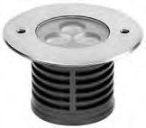  UG09A | 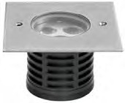  UG09AS
Golden Barrel UG09 | 3*3W - Cutout D102mm D116*H73mm  MS: D102*H150mm | 3*3W - Cutout D102mm F116*H73mm  MS: D102*H150mm

Corn cob UG10 | 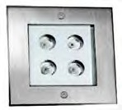  UG10A | 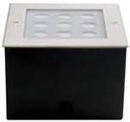  UG10B
Corn cob UG10 | 4*2W - Cutout F112mm F125*H75mm  MS: F112*H95mm | 9*2W - Cutout F152mm F160mm  MS: F152*H112mm

Echinopsis UG11 | 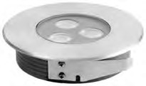  UG11A | 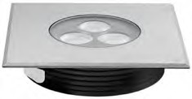  UG11AS
Echinopsis UG11 | 3*2W - Cutout D104mm | 3*2W - Cutout D104mm F116*H3| 8mm

Zebra plan UG12 | 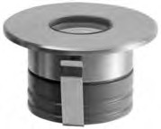  UG12A | 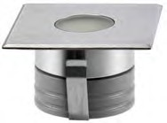  UG12AS
Zebra plan UG12 | 2W  D58*H43mm | 2W  F58*H43mm

Ferocactus UG13 | 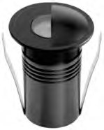  UG13A | 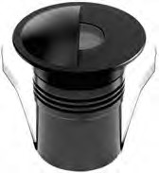  UG13B
Ferocactus UG13 | 3W - Cutout D80mm D55*H82mm  MS: D80*H115mm | 6W - Cutout D136mm D70*H82mm  MS: D136*H133
Coral UG15 | 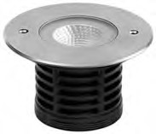  UG15A | 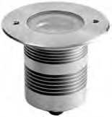  UG15B
Coral UG15 | 8W - Cutout D102mm D116*H73mm  MS: D102*H150mm | 15W - Cutout D102mm D116*H98mm  MS: D102*H150mm

Brevicaule UG16 | 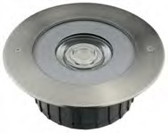  UG16A | 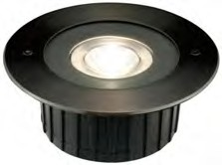  UG16B
Brevicaule UG16 | 20W - Cutout D157mm D173*H77mm  MS: D156.5*H149mm | 25W - Cutout D172mm D185*H92mm  MS: D171.5*H120mm

Ruby UG17 | 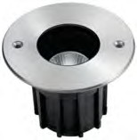  UG17A | 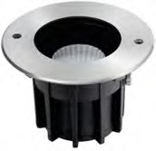  UG17B | 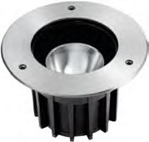  UG17C | 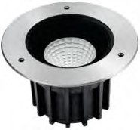  UG17D | 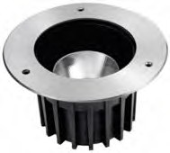  UG17E | 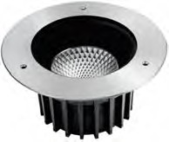  UG17F
Ruby UG17 | 5W - Cutout D85mm D95*H116mm  MS: D85*H118mm | 10W - Cutout D119mm D130*H133mm  MS: D119*H136mm | 15W - Cutout D147mm D160*H153mm  MS: D147*H156mm | 20W - Cutout D165mm D180*H162mm  MS: D165*H168mm | 25W - Cutout D193mm D210*H181mm  MS: D193*H194mm | 30W - Cutout D223mm D250*H190mm  MS: D223*H212mm

Cuspidata UG18 | 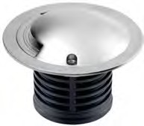  UG18A | 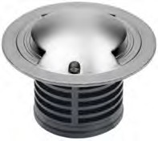  UG18B | 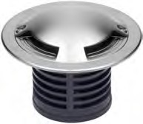  UG18C
Cuspidata UG18 | 8W - Cutout D102mm D116*H73mm  MS: D102*H150mm | 15W - Cutout D102mm D116*H98mm  MS: D102*H150mm | 15W - Cutout D102mm D116*H98mm  MS: D102*H150mm

White fox UG20 | 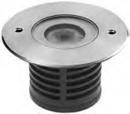  UG18A | 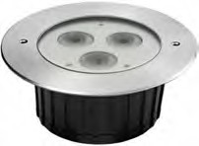  UG18B | 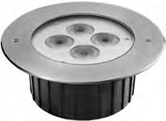  UG18C
White fox UG20 | 1*6W - Cutout D102mm D116*H73mm  MS: D102*H150mm | 3*6W - Cutout D157mm D173*H77mm  MS: D156.5*H149mm | 4*6W - Cutout D172mm D185*H92mm  MS: D171.5*H120mm




export.hitech-vn.com
|
sales@hitech-vn.com
|
+84 24 73018681

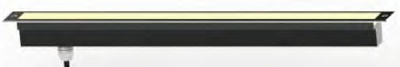
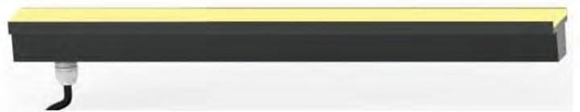
Puff
BL-A&L-UG22
Puff
BL-A&L-UG22

Gasteria UG21 | 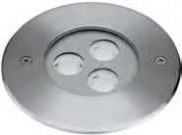  UG21A | 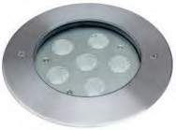  UG21B | 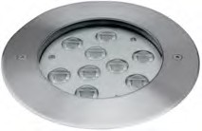  UG21C | 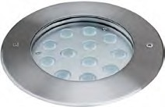  UG21D | 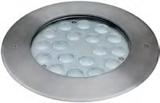  UG21E | 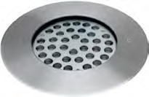  UG21F
Gasteria UG21 | 3*2W D116*H73mm  MS: D102*H150mm | 6*2W D173*H77mm  MS: D156.5*H149mm | 9*2W D173*H77mm  MS: D156.5*H149mm | 12*2W D180*H162mm MS: D165*H168mm | 25W - Cutout D193mm D210*H181mm  MS: D193*H194mm | 30W - Cutout D223mm D250*H190mm  MS: D223*H212mm

Puff UG22 | 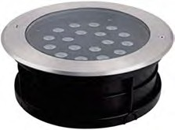  UG22A | 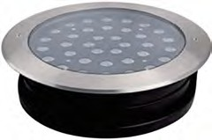  UG22B
Puff UG22 | 24*1W D260*H80mm MS: D234*H90mm | 36*1W D320*H80mm MS: D292*H90mm

Golden UG23 | UG23A | UG23B
Golden UG23 | 6/12/24*3W L300/560/1080*W55mm MS: W59*H87mm | 6/12/24*3W L337/580/1120*W90mm MS: W83*H97mm

Ferocactus UG24 | UG24A | UG24B
Ferocactus UG24 | 5/10/20W L261/522/1044*W50mm MS: W59*H87mm | 5/10/20W L306/549/1089*W75mm MS: W83*H97mm

Elongata UG25 | 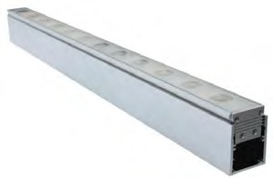  UG25A
Elongata UG25 | 6/12/24*3W L275/500/1000*W32*H32mm MS: W37.5*H49mm

Calico UG27  (Beam angle ADJ) | 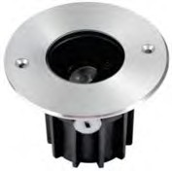  UG27A | 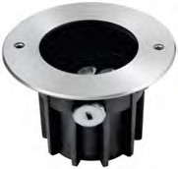  UG27B | 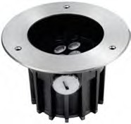  UG27C | 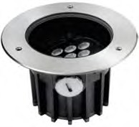  UG27D | 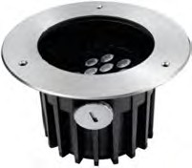  UG27E | 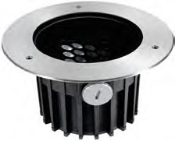  UG27F
Calico UG27  (Beam angle ADJ) | 1*3W D95*H116mm MS: D85*H118mm | 3*3W D130*H133mm MS: D119*H136mm | 6*3W D160*H153mm MS: D147*H156mm | 9*3W D180*H162mm MS: D165*H168mm | 12*3W D210*H181mm MS: D193*H194mm | 18*3W D250*H190mm MS: D223*H212mm

Red pagoda UG28  (Beam angle ADJ) | 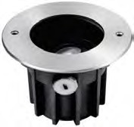  UG28A | 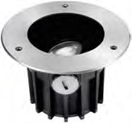  UG28B | 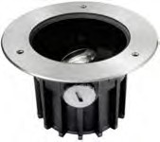  UG28C | 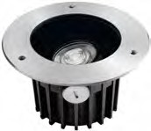  UG28D | 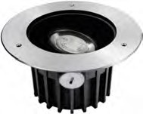  UG28E
Red pagoda UG28  (Beam angle ADJ) | 10W D130*H133mm MS: D119*H136mm | 15W D160*H153mm MS: D147*H156mm | 20W D180*H162mm MS: D165*H168mm | 25W D210*H181mm MS: D193*H194mm | 30W D250*H190mm MS: D223*H212mm

export.hitech-vn.com
|
sales@hitech-vn.com
|
+84 24 73018681

Shark tooth UG29 | 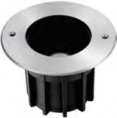  UG29A | 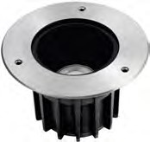  UG29B | 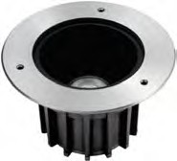  UG29C | 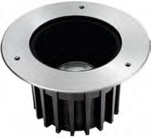  UG29D | 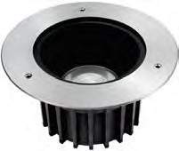  UG29E
Shark tooth UG29 | 10W D130*H133mm MS: D119*H136mm | 15W D160*H153mm MS: D147*H156mm | 20W D180*H162mm MS: D165*H168mm | 25W D210*H181mm MS: D193*H194mm | 30W D250*H190mm MS: D223*H212mm

Ovata UG30 | 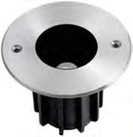  UG30A | 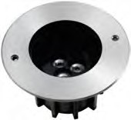  UG30B | 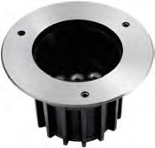  UG30C | 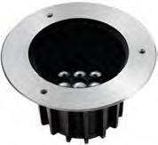  UG30D | 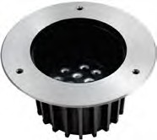  UG30E | 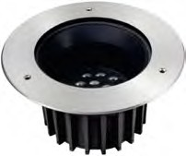  UG30F
Ovata UG30 | 1*3W D90*H116mm MS: D85*H118mm | 3*3W D130*H133mm MS: D119*H136mm | 6*3W D160*H153mm MS: D147*H156mm | 9*3W D180*H162mm MS: D165*H168mm | 12*3W D210*H181mm MS: D193*H194mm | 18*3W D250*H190mm MS: D223*H212mm

Jade plant UG31 | 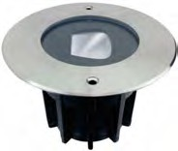  UG31A | 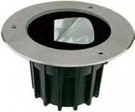  UG31B | UG31C
Jade plant UG31 | 10W D160*H153mm MS: D147*H156mm | 15W D180*H162mm MS: D165*H168mm | 20W D210*H181mm MS: D193*H194mm

Jade plant UG33 | 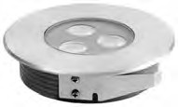  UG33A | 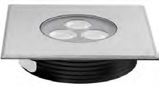  UG33AS | 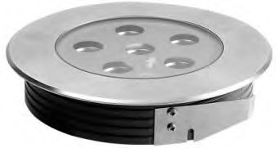  UG33B | 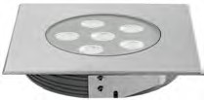  UG33BS
Jade plant UG33 | 3*2W Cutout D104mm D116*H38mm | 3*2W Cutout D104mm F116*H38mm | 6*3W Cutout D156mm D173*H38mm | 6*3W Cutout D156mm F173*H38mm
Blood sedum UG35 | 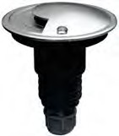  UG35A (1side) | 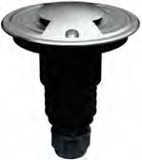  UG35B (2side)
Blood sedum UG35 | 3W Cutout D110mm D70*H86mm  MS: D110*H100mm | 3W Cutout D110mm D70*H86mm  MS: D110*H100mm

Ivory UG32 | 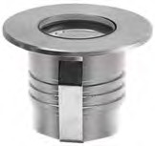  UG32A | 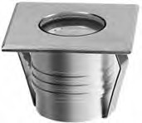  UG32AS
Ivory UG32 | 2W Cutout D40mm D50*H42mm | 2W Cutout D40mm F50*H42mm

export.hitech-vn.com
|
sales@hitech-vn.com
|
+84 24 73018681




UNDERWATER LIGHT (UW)

Corpus UW02 | 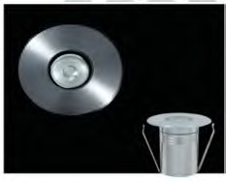  UW02A | 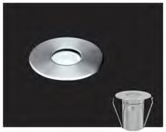  UW02B | 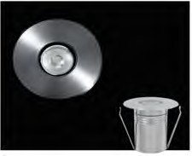  UW02C | 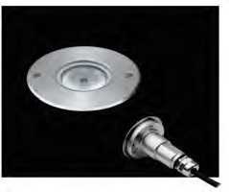  UW02D
Corpus UW02 | 2W - Cutout D50mm D38*H65mm  MS: D50*H83mm | 2W - Cutout D80mm D55*H82mm  MS: D98*H80mm | 2W - Cutout D136mm D70*H82mm  MS: D136*H133mm | 2W - Cutout D110mm D67.5*H88mm  MS: D110*H100mm

Cularia UW03 | 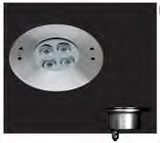  UW03A | 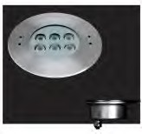  UW03B | 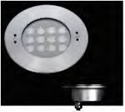  UW03C | 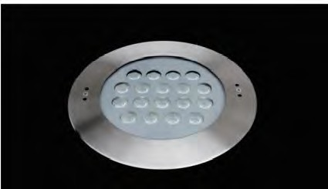  UW03D | 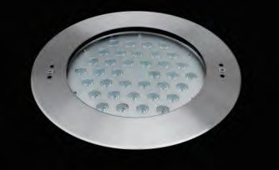  UW03E
Cularia UW03 | 4*2W D135*H58mm  MS: D127*H120mm | 6*2W D180*H77mm  MS: D156*H120mm | 12*2W D205*H88mm  MS: D169*H126mm | 18*2W D250*H79mm  MS: D232*H126mm | 36*1.5W D250*H79mm  MS: D232*H126mm

Pack Podium UW04 | 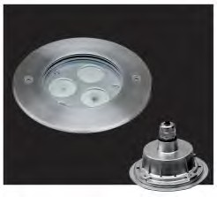  UW04A | 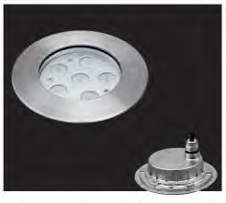  UW04B | 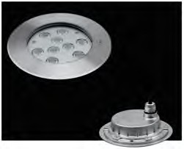  UW04C | 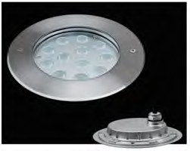  UW04D | UW04E
Pack Podium UW04 | 3*2W D118*H55mm  MS: D110*H118mm | 6*2W D162*H65mm MS: D146*H95mm | 9*2W D162*H65mm MS: D146*H95mm | 12*2W D185*H65mm  MS: D171.5*H120mm | 18*2W D185*H65mm  MS: D171.5*H120mm

Graptose Dum UW06 | 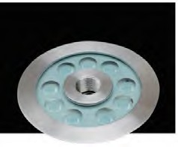  UW06A | 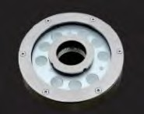  UW06B | 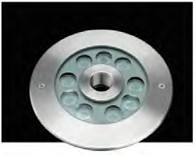  UW06C | 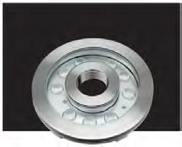  UW06D | 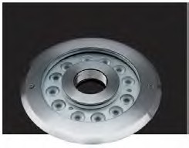  UW06E
Graptose Dum UW06 | 9*2W D149*H61.5mm | 9*2W D160*H36mm | 9*2W D170*H61.5mm | 9*2W D182*H65mm | 12*2W D200*H65mm
Elephant Bush UW07 | 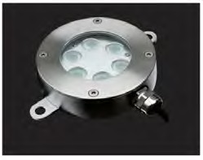  UW07A
Elephant Bush UW07 | 6*2W D115*H32mm

Bones UW09 | 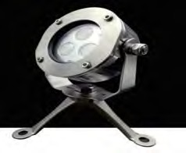  UW09A | 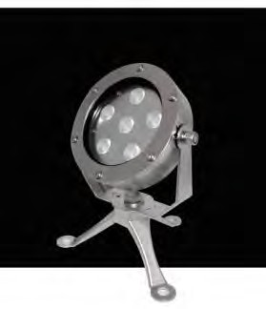  UW09B
Bones UW09 | 3*2W  D113mm | 6*2W  D153mm


export.hitech-vn.com
|
sales@hitech-vn.com
|
+84 24 73018681

Brevicaule UW05 | 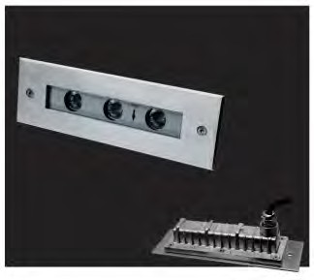  UW05A | 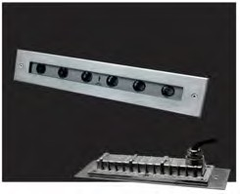  UW05B | 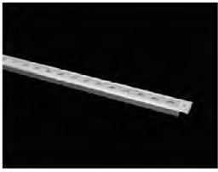  UW05C | 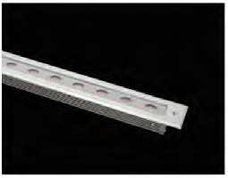  UW05D
Brevicaule UW05 | 3*2W L195*W63*H65mm MS: L180*W58*H90mm | 6*2W L328*W63*H65mm MS: L313*W58*H90mm | 12*1.5W L600*W115*H105mm | 24*1.5W L1050*W115*H105mm
Hatiora UW08 | 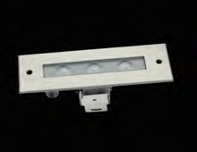  UW08A | 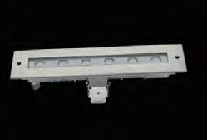  UW08B
Hatiora UW08 | 3*2W L195*W63*H65mm | 6*2W L328*W63*H65mm

Tree Euphorbia UW11 | 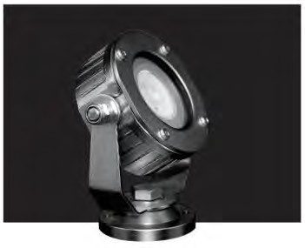  UW11A
Tree Euphorbia UW11 | 1*4W  D113mm

Salicornioides UW10 | 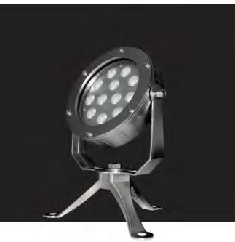  UW10A | 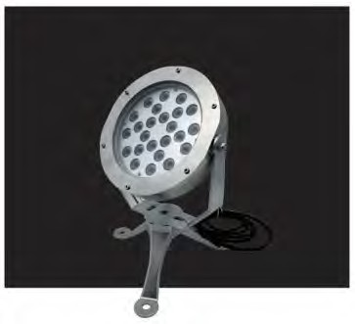  UW10A
Salicornioides UW10 | 12*2W  D180mm | 18*2W  D220mm

Brevifo UW01 | 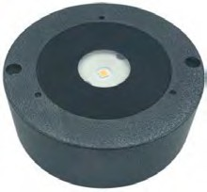  UW01
Brevifo UW01 | 12W-20W  D89*H37mm

export.hitech-vn.com
|
sales@hitech-vn.com
|
+84 24 73018681

WALL LIGHT (WL)

WL01 | 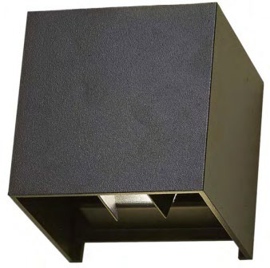  WL01
WL01 | 2*3W L100*W100*H100mm

WL09 | 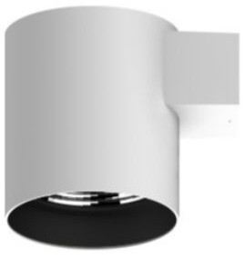  WL09A | WL09B | WL09C
WL09 | 10W-15W D123xH156mm | 15W-20W D160xH183mm | 20W-25W D200xH212mm

WL04 | 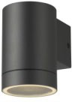  WL04A | 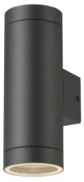  WL04B
WL04 | 35W L10.6*D7.6*H11.6mm | 35W L10.6*D7.6*H20.7mm

WL05 | 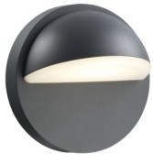  WL05
WL05 | 8.5W  L18*W11*H18mm

WL14 | 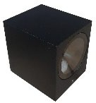  WL14-1S (Square, Black) | 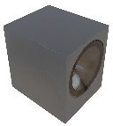  WL14-1S (Square, Grey) | 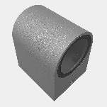  WL14-1S (Cricle, Grey) | 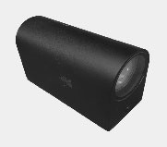  WL14-2S (Cricle, Black) | 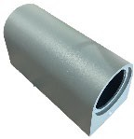  WL14-2S (Cricle, Grey)
WL14 | 4.6W; IP65; 3000K W63*H80*L75 | 4.6W; IP65; 3000K W63*H80*L75 | 4.6W; IP65; 3000K W60*H77*75 | 2*4.6W; IP65; 3000K W66*H96*150 | 2*4.6W; IP65; 3000K W66*H96*150
 |  |  |  | 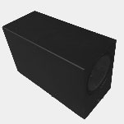  WL14-2S (Square, Black) | 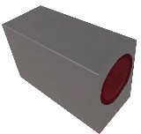  WL14-2S (Square, Grey)
 |  |  |  | 2*4.6W; IP65; 3000K W65*H90*150 | 2*4.6W; IP65; 3000K W65*H90*150
WL03 | 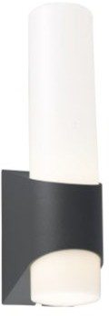  WL03A | 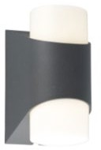  WL03B
WL03 | 11W H12.7*W8.2*H16.5mm | 11W H12.7*W8.2*H31mm

WL02 | 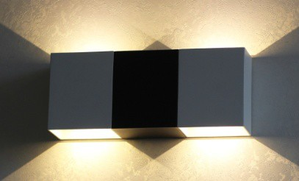  WL02
WL02 | 4W*2 H22.5*W22.7*H9mm

export.hitech-vn.com
|
sales@hitech-vn.com
|
+84 24 73018681

WATERPROOF LIGHT

Aster BL-WP01 | 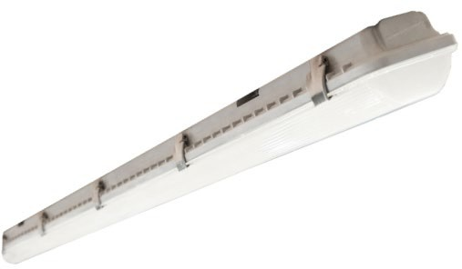  BL-WP01 | BL-WP01 | BL-WP01 | BL-WP01
Aster BL-WP01 | 8W L1265*W120*H75mm | 16W (2*8) L1265*W120*H75mm | 14W L1265*W120*H75mm | 28W (2*14) L1265*W120*H75mm

Pansy BL-WP02 | 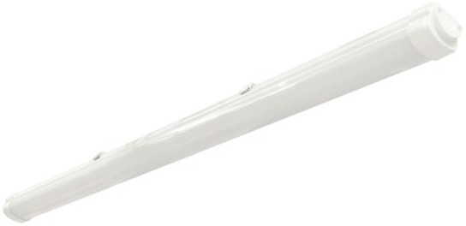  BL-WP02 | BL-WP02
Pansy BL-WP02 | 18W L1200*W75*H60mm | 36W L1200*W75*H60mm

Bluebell BL-WP03 | 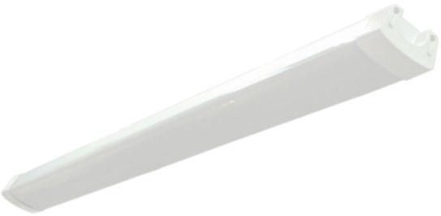  BL-WP03 | BL-WP03 | BL-WP03 | BL-WP03
Bluebell BL-WP03 | 18W L1250*W100*H60mm | 36W (2*8) L1250*W100*H60mm | 60W L1250*W100*H60mm | 80W (2*14) L1250*W100*H60mm

BL-WP04 | 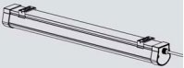  BL-WP04 | BL-WP04 | BL-WP04
BL-WP04 | 18W L600*W65*H60mm | 36W L1200*W65*H60mm | 45W L1500*W65*H60mm

export.hitech-vn.com
|
sales@hitech-vn.com
|
+84 24 73018681

