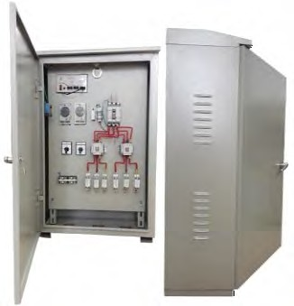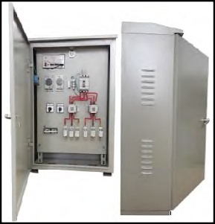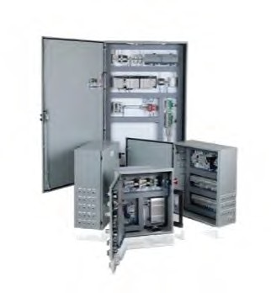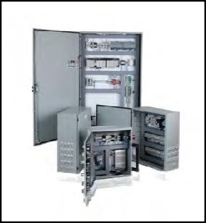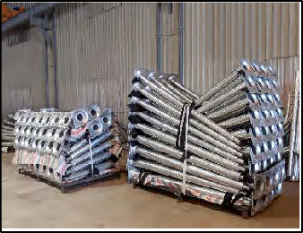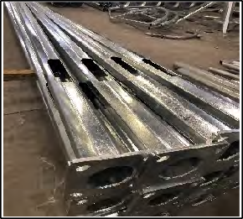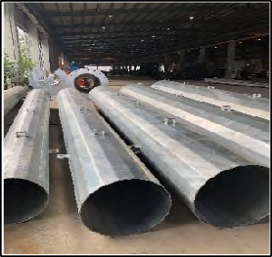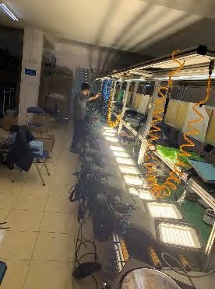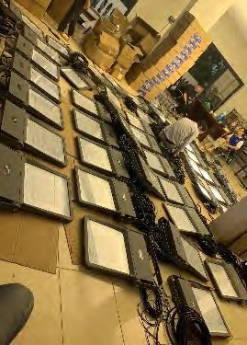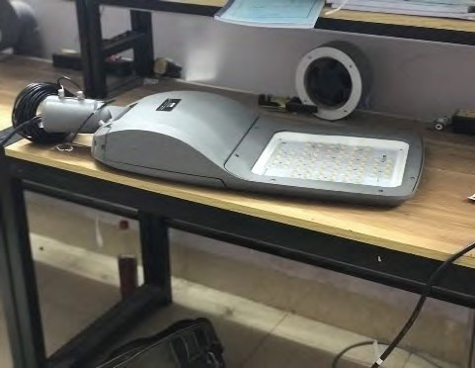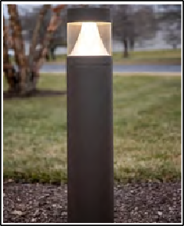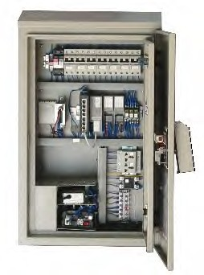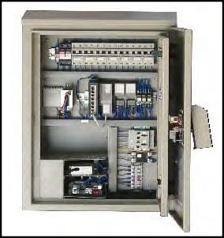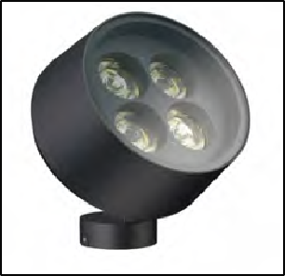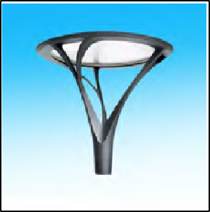HITECH VIETNAM CONSULTANT - TRADE AND CONSTRUCTION JSC.

FABRICATION AND EXPORT

Lighting steel and Aluminum pole

Lighting Luminaire

Control Cabinet
____________________________________________________________
export.hitech-vn.com | sales@hitech-vn.com | +84 24 73018681

INTRODUCTION

HITECH VIETNAM Consultant – Trade and Construction Jsc is an export company of Lighting products and steel structures such as:
- Producing, processing and exporting steel poles, lighting poles and steel structures serving in the field of communication and power transmission such as viba poles, monopoles,...
- Producing all kinds of indoor and outdoor lighting, such as LED street lighting, floodlight, post-top, bollard, etc
- Consulting, designing, manufacturing and installing manuals for operating lighting cabinets, lighting control centers, building intelligent control cabinets, traffic signal control cabinets, technical cabinets and control systems of smart devices.
- Processing production orders according to the available designs of customers.

With a team of agile, qualified and experienced personnel in the market and lean manufacturing capabilities to meet high demand thanks to extensive cooperation with satellite manufacturing facilities, HITECH VIETNAM has satisfied domestic and foreign customers and partners.

With the goal of sustainable development close to nature, protecting the environment and bringing the best values to customers, since its inception, Hitech Vietnam has built a vision and mission for businesses, specific:
- Professional consulting
- Creative design
- High quality product
- Friendly with the nature, protecting environment.

HITECH VIETNAM
Chairman of Board
NGUYEN MINH HUE

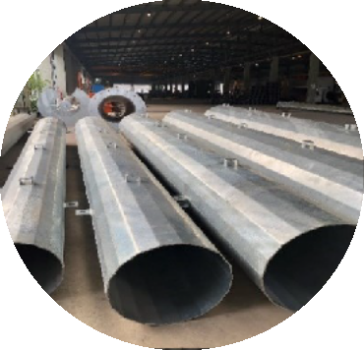PRODUCTION CAPACITY OF STEEL POLE

Design, technical management
- Researching and developing new products and technologies
- Technical management.
- Making 2D, 3D drawings, processing programs.

Design capacity
- Software CAD, CAM, CAE (copyright) .
- 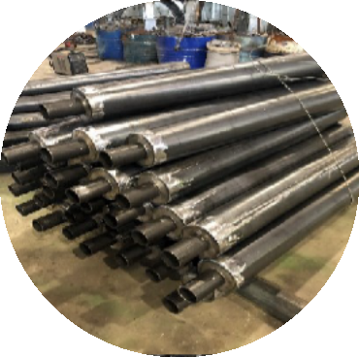3D model design, 2D drawings
- Calculate durability, displacement, temperature, optics…
- Motion simulation
- Mold design, jigs

Quality control
- Checking product quality at each of stage and finishing.
  - Checking and testing product specification
- Quality management
- 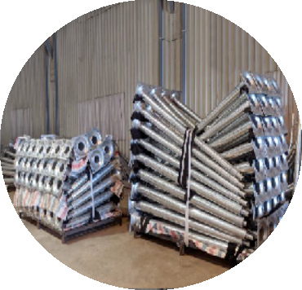Product warranty

Testing abilities
  - Plating test
  - Ultrasonic weld inspection
  - Testing, analyzing materials
  - Testing electrical parameters
  - Testing optical parameters
  - Testing mechanical parameters

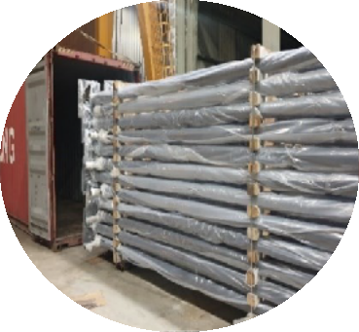Packing and exporting
- Packing according to sea export standards to ensure goods safety.

PRODUCTION CAPACITY OF LIGHTING AND CONTROLLER CABINET

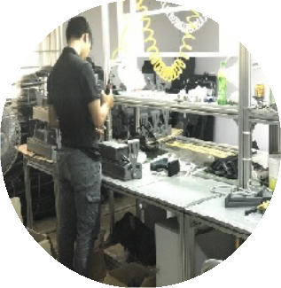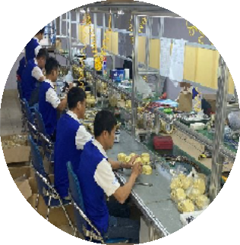Lighting luminaire
  - Body and lamp cover are manufactured by high pressure aluminum die-casting technology.
  - Processing plastic products, such as lamp glass, PMMA plastic ball, heat-resistant PC, hot- pressed composite lamp shell, with large size, aging resistance, impact resistance, UV resistance
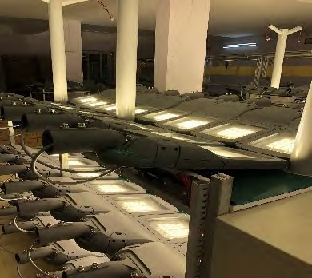
  - 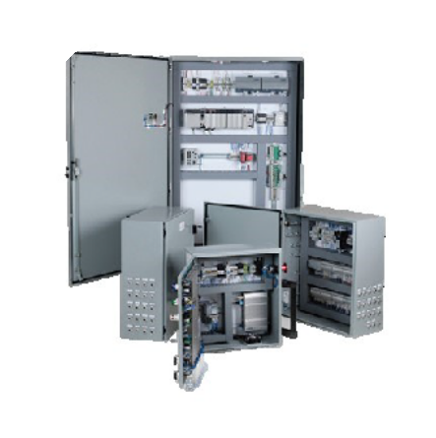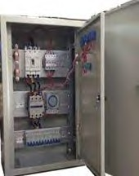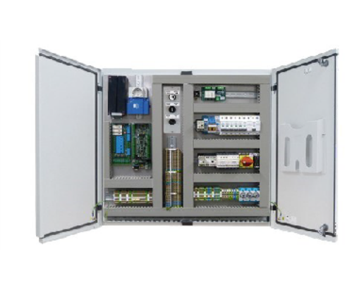Human labor resource with high skill, well- trained, experienced in manufacturing lighting products, along with the capacity of machinery and equipment, Hitech completely masters the processing and manufacturing, mechanical details, tools, molds, jigs for the production of own products, ensuring high accuracy, meeting all the strictest requirements of domestic and foreign customers.

Controller cabinet
- Hitech Vietnam Company specializes in consulting, designing, manufacturing and installing manuals for operating lighting control cabinets, traffic signal control cabinets and security surveillance camera cabinets.
- Experienced team of engineers and technicians.
- Detailed and precise technical cabinet design brings high efficiency when used
- Ensuring safety standards on electricity and insulation, the cabinet meets the ability to operate in different environmental conditions.

